**T. Satya Himavanth**

**Y20CS179**

**HTML**

1.

a. Create a web page having the background in green and title “My First Page”.

b. Create a web page of pink colour and display a moving message in red colour.

c. Design a web page containing text, in form of paragraphs giving suitable heading style.

Codes and outputs:

a.

<html>

    <head>

        <title>My First Page</title>

    </head>

    <body style="background-color: #00FF00;">

    </body>

</html>

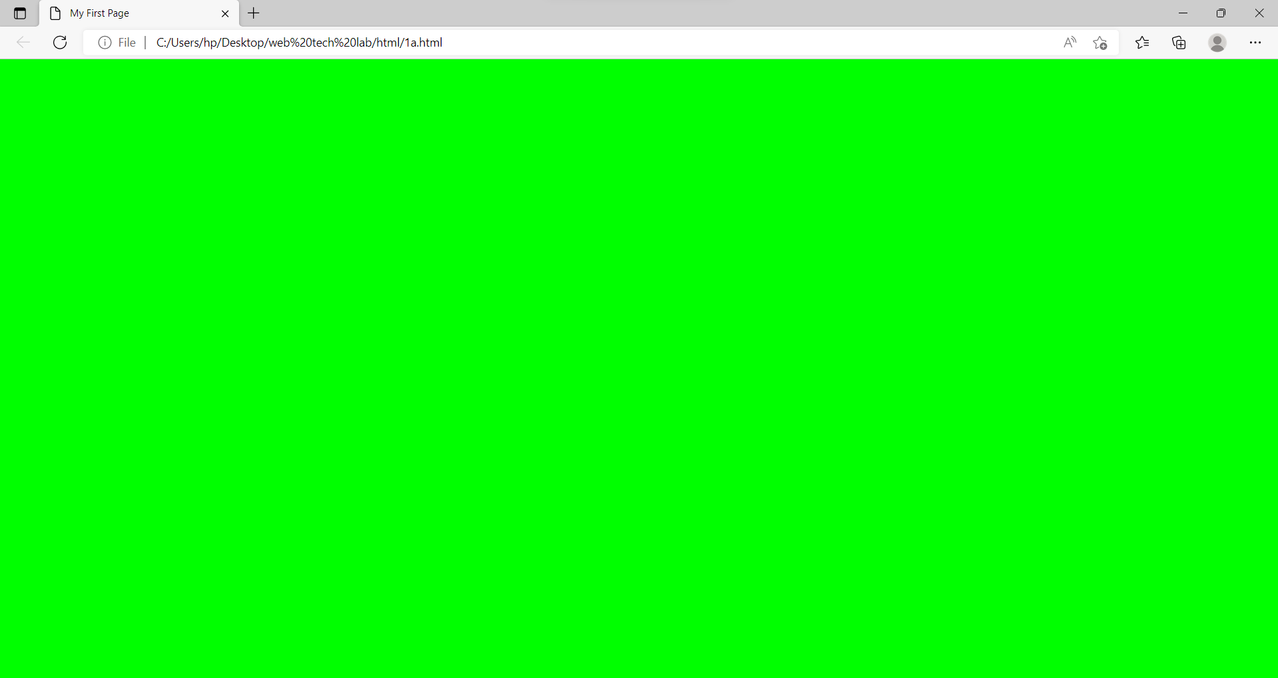

b.

<html>

    <head>

    </head>

    <body style="background-color: #ff00c8;">

        <h2>Moving message</h2>

        <marquee style="color:#ff0000;">

            R.V.R and J.C College of Engineering

        </marquee>

    </body>

</html>

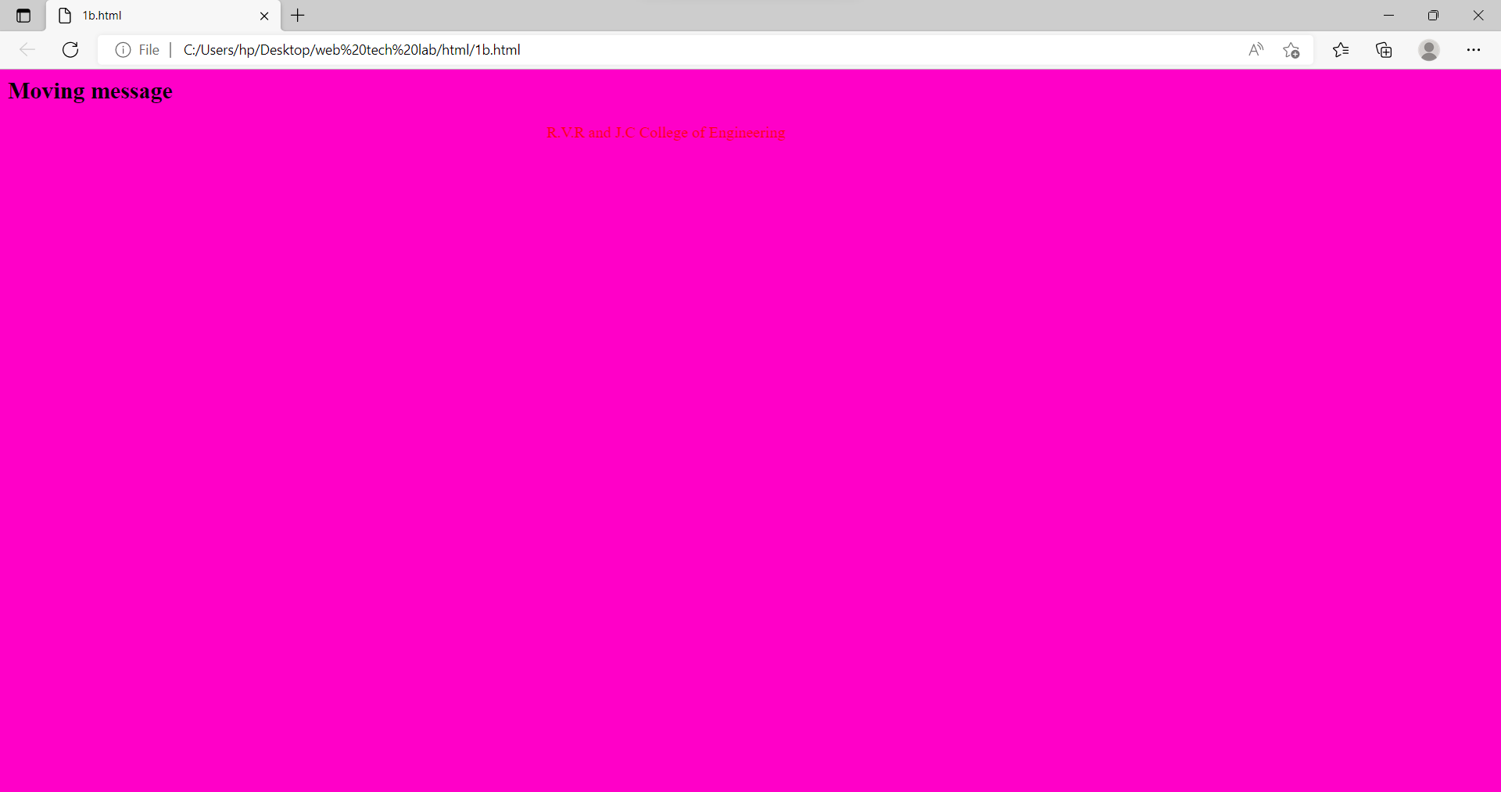

c.

<html>

    <head>

    </head>

    <body>

        <h1>About HTML</h1>

        <p>HTML is the combination of Hypertext and Markup language.</p>

        <p>Hypertext defines the link between the web pages.</p>

        <p>A markup language is used to define the text document within tag which defines the structure of web pages.</p>

        <h2>Javascript</h2>

        <p>JavaScript was initially created as a browser-only language, but it is now used in many other environments as well.<br>Today, JavaScript has a unique position as the most widely-adopted browser language with full integration in HTML/CSS.</p>

    </body>

</html>

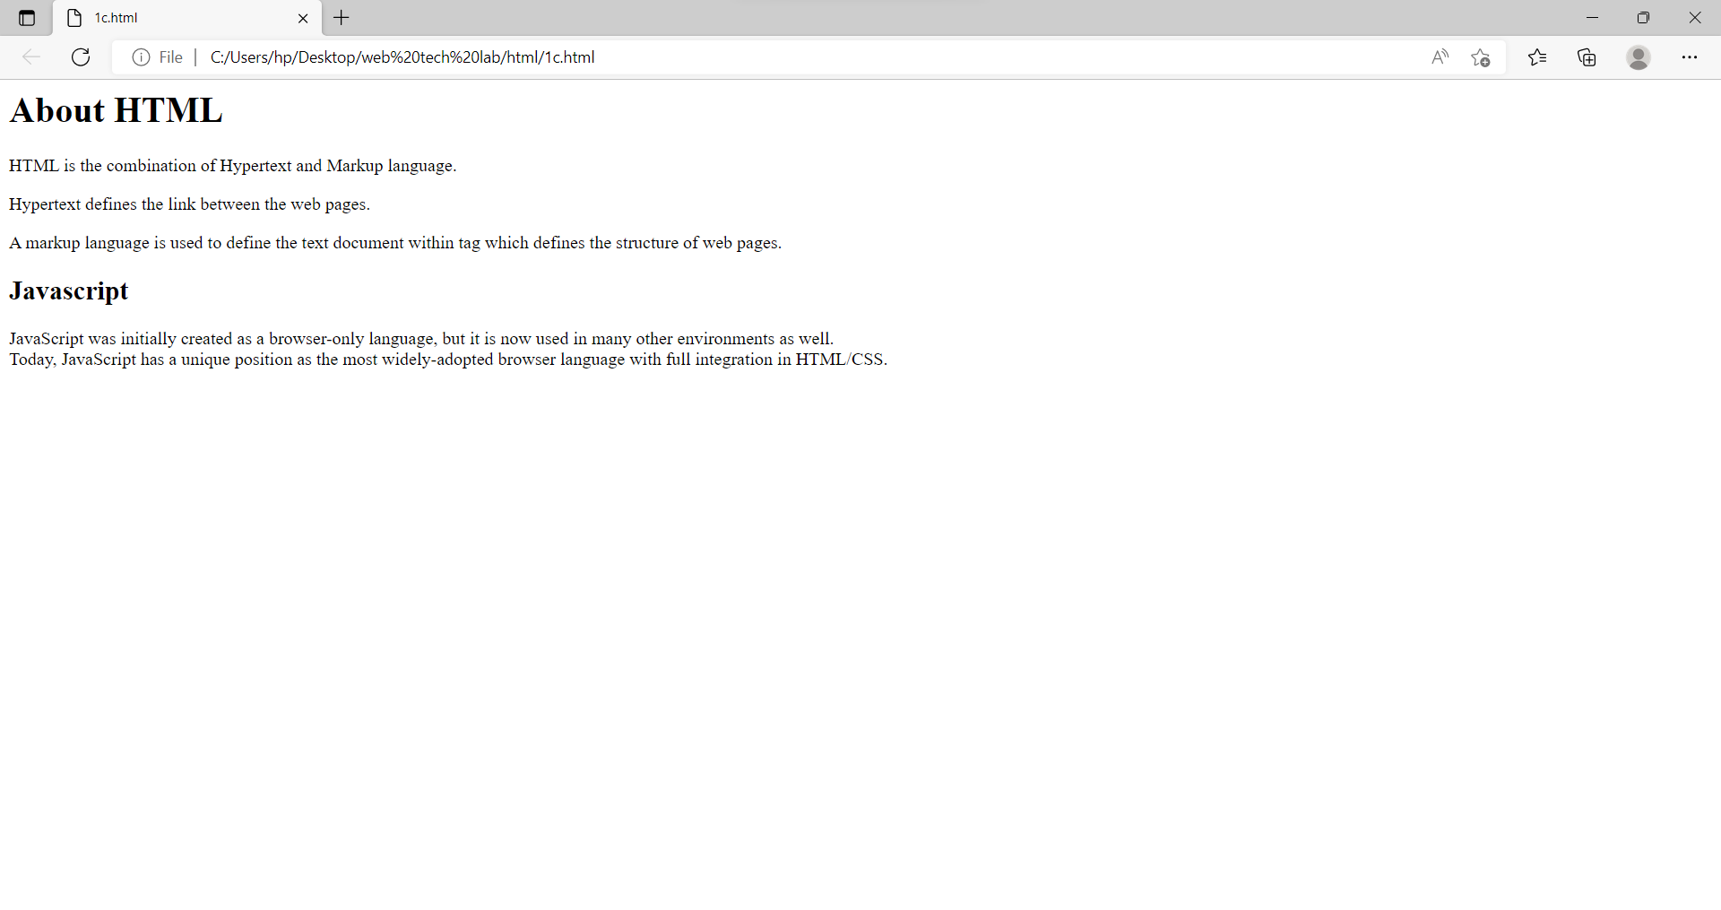

2.

a. Create a web page which displays WELCOME text using heading tags(h1 to h6)

b. Create a web page which displays WELCOME text using tag

c. Create a web page which displays h2o and x2+y2 using tag

Code and output:

a.

<html>

    <head>

    </head>

    <body>

        <h1>WELCOME</h1>

        <h2>WELCOME</h2>

        <h3>WELCOME</h3>

        <h4>WELCOME</h4>

        <h5>WELCOME</h5>

        <h6>WELCOME</h6>

    </body>

</html>

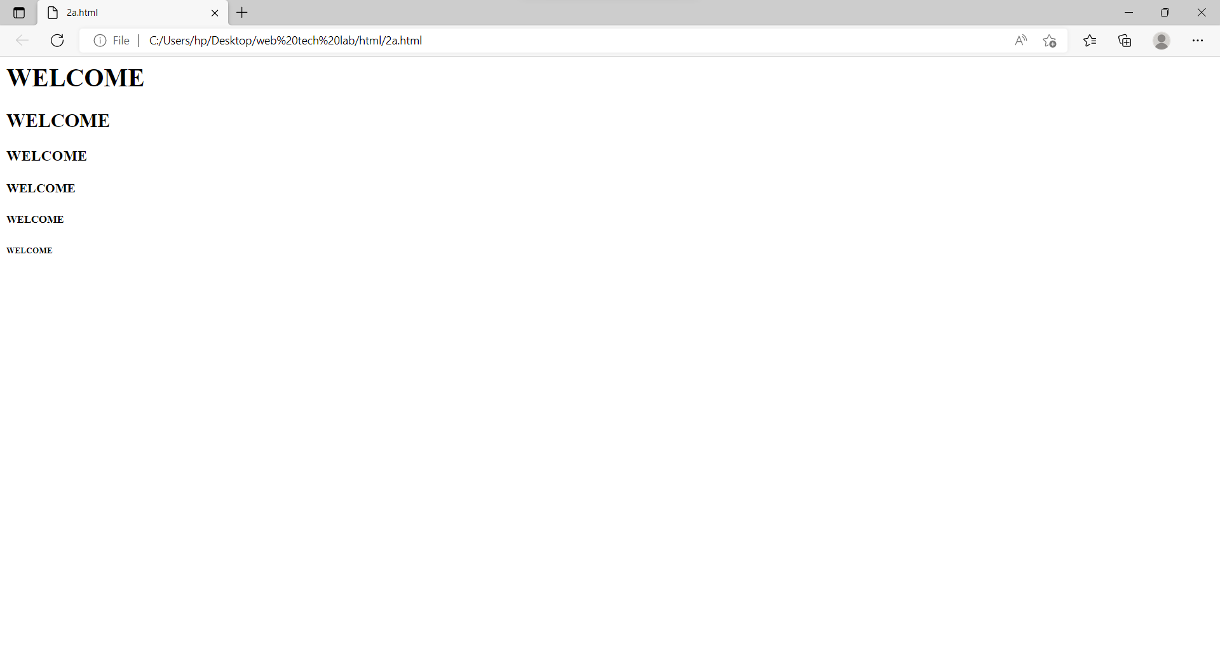

b.

<html>

    <head>

    </head>

    <body>

        <p><b>Bold</b> Text</p>

    </body>

</html>

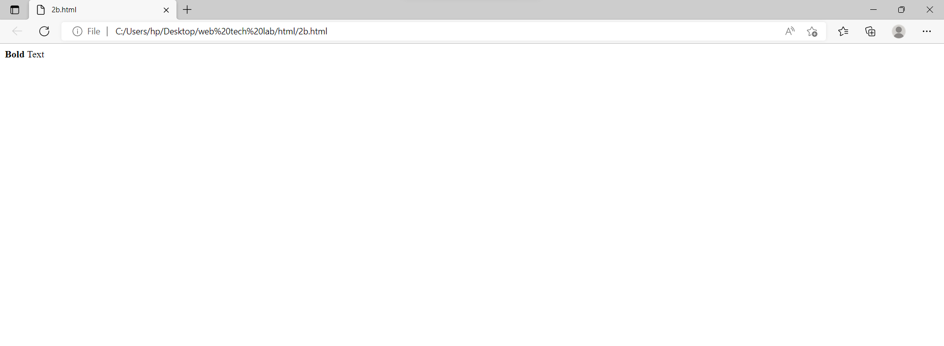

c.

<html>

    <head>

    </head>

    <body>

        <p>H<sub>2</sub>O</p>

        <p>x<sup>2</sup>y<sup>2</sup></p>

    </body>

</html>

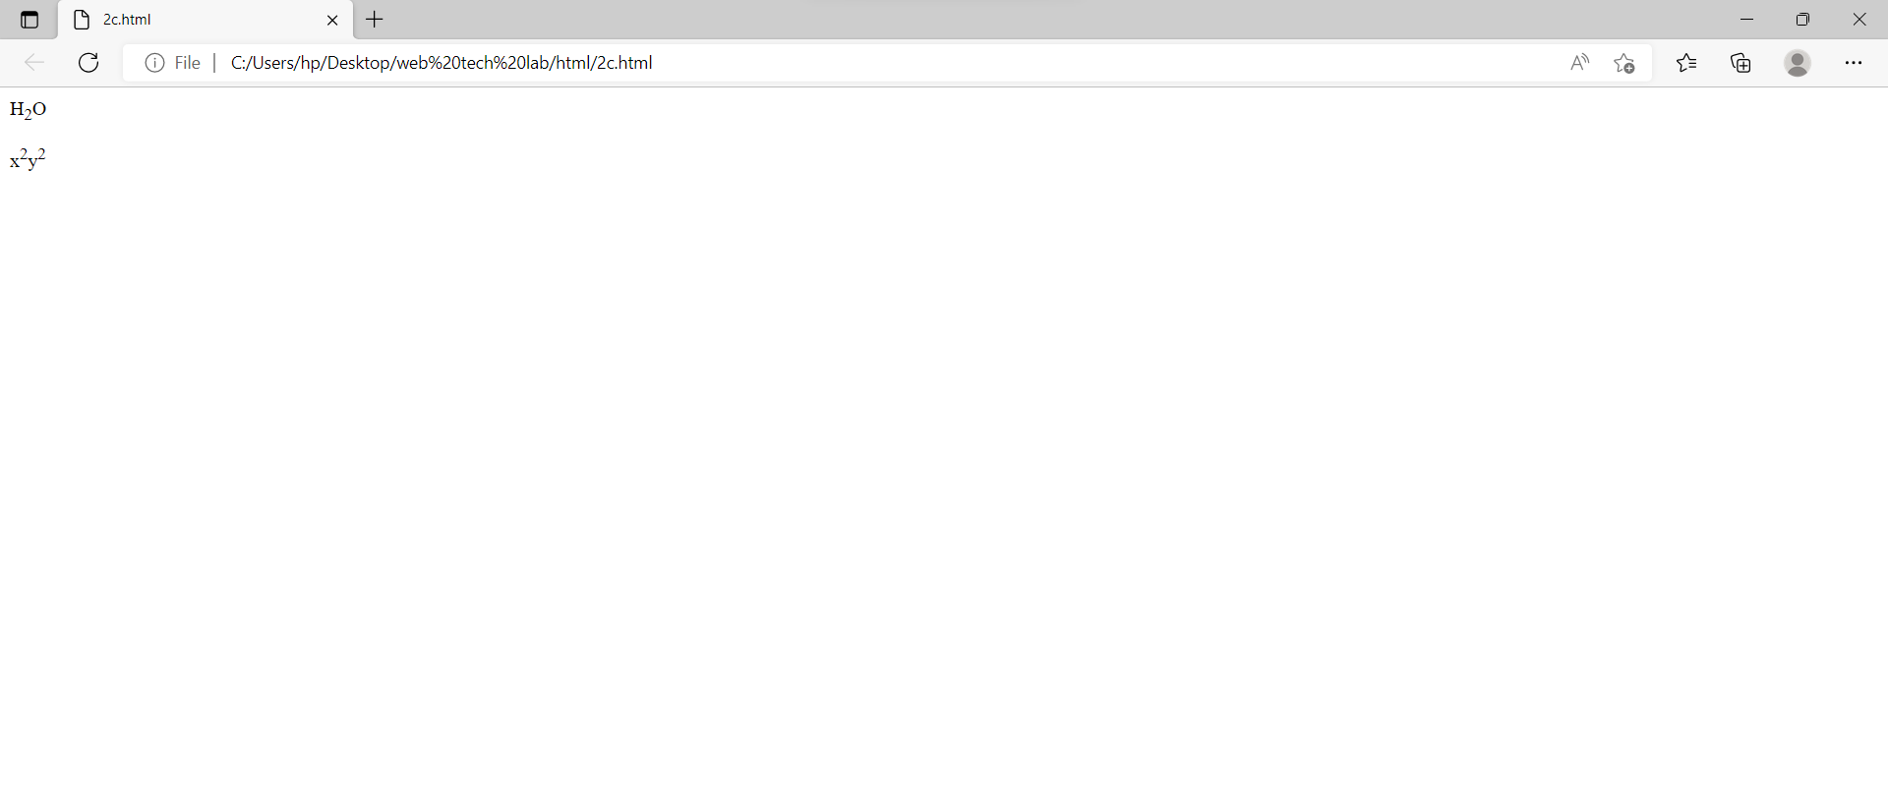

3.

a. Create a web page to show different attributes of Font tag.

b. Create a web page to show different attributes: italics, bold, underline.

c. Design a web page having background colour yellow and giving text colour red.

Codes and outputs:

a.

<html>

    <head>

    </head>

    <body>

        <p style=color:#ff4d00>Red color paragraph.</p>

        <p style=background-color:aqua>Blue paragraph.</p>

        <p style="font-family:courier;">Font style paragraph.</p>

        <p style="font-size:300%;">Font size paragraph.</p>

        <p style="text-align:right;">right paragraph.</p>

    </body>

</html>

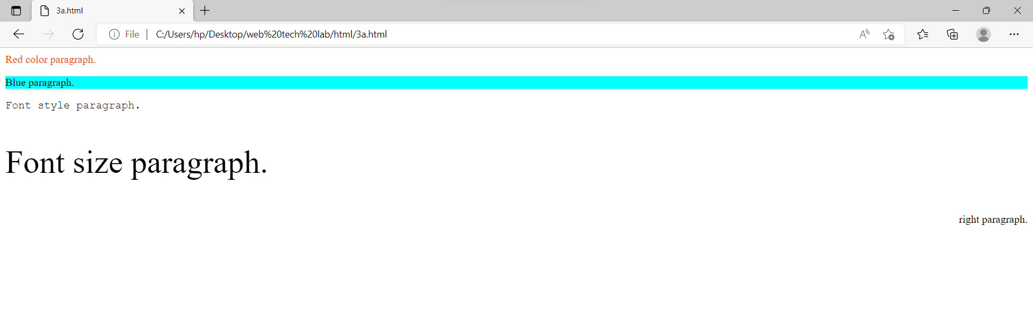

b.

<html>

    <head>

    </head>

    <body>

        <p><i>Text</i></p>

        <p><b>Text</b></p>

        <p><u>Text</u></p>

    </body>

</html>

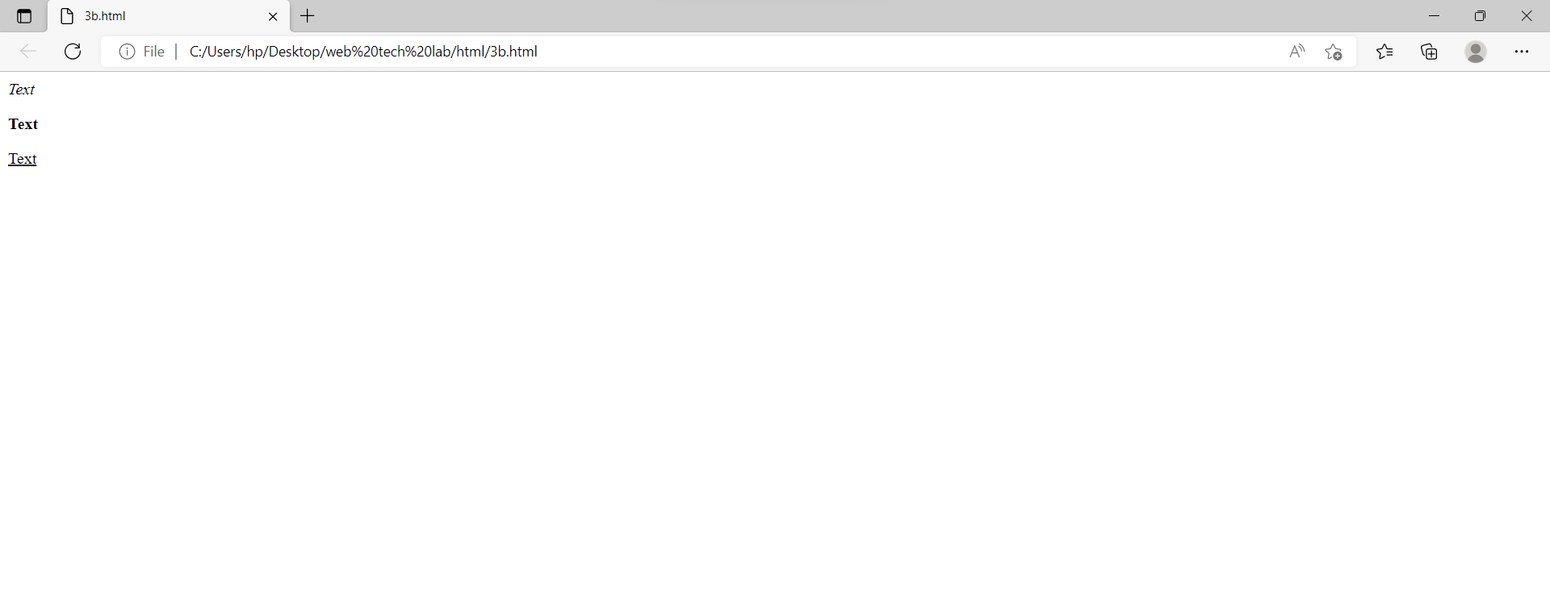

c.

<html>

    <head>

    </head>

    <body style="background-color:yellow">

        <p style="color:red">Text</p>

    </body>

</html>

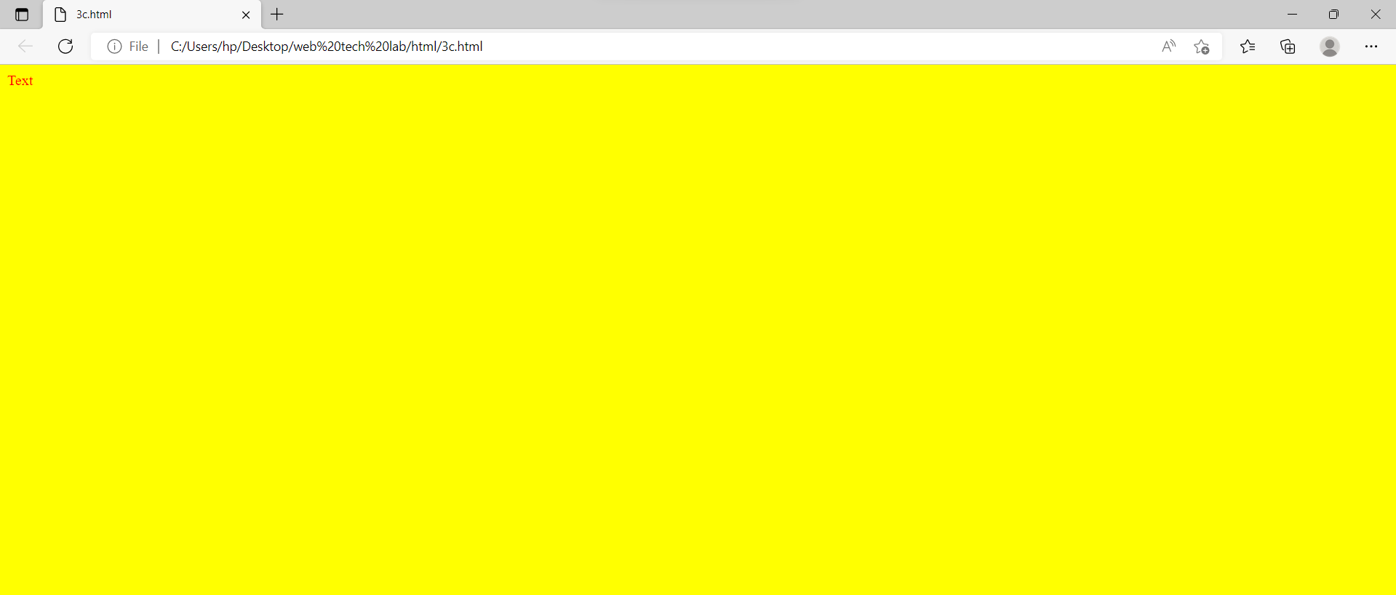

4.

a. Create a web page using href attribute of anchor tag & the attribute: alink, vlink etc.

b. Create links on the words e.g. ―Wi-Fi and ―LAN‖ to link them to Wikipedia pages.

c. Create a web page with appropriate content and insert an image towards the lefthand side of the page. When user clicks on the image, it should open another Web page.

Codes and outputs:

a.

<html>

    <head>

        <style>

            a:link {

                color: rgb(255, 0, 0);

                background-color: transparent;

                text-decoration: underline;

            }

            a:visited {

                color: #fffb00;

                background-color: transparent;

                text-decoration: none;

            }

            a:hover {

                color: hsl(130, 100%, 50%);

                background-color: transparent;

                text-decoration: underline;

            }

            a:active {

                color: hwb(183 0% 0%);

                background-color: transparent;

                text-decoration: none;

            }

        </style>

    </head>

    <body>

        <p>Changing colors of link</p>

        <a href="https://rvrjcce.ac.in/" target="_blank">R.V.R and J.C College Of Engineering</a>

    </body>

</html>

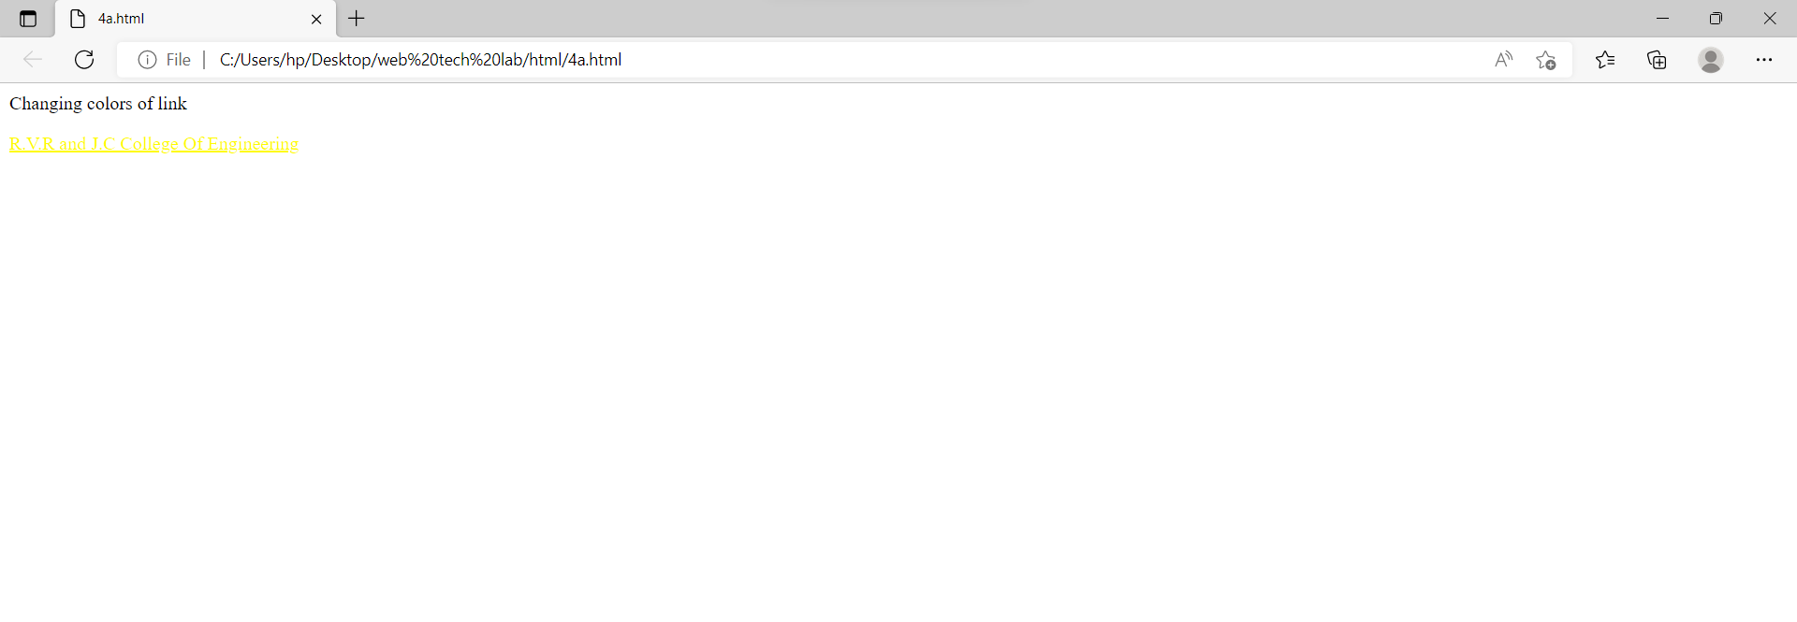

b.

<html>

    <head>

    </head>

    <body>

        <a href="https://en.wikipedia.org/wiki/Wi-Fi">Wi-Fi</a><br><br>

        <a href="https://en.wikipedia.org/wiki/Local_area_network">LAN</a>

    </body>

</html>

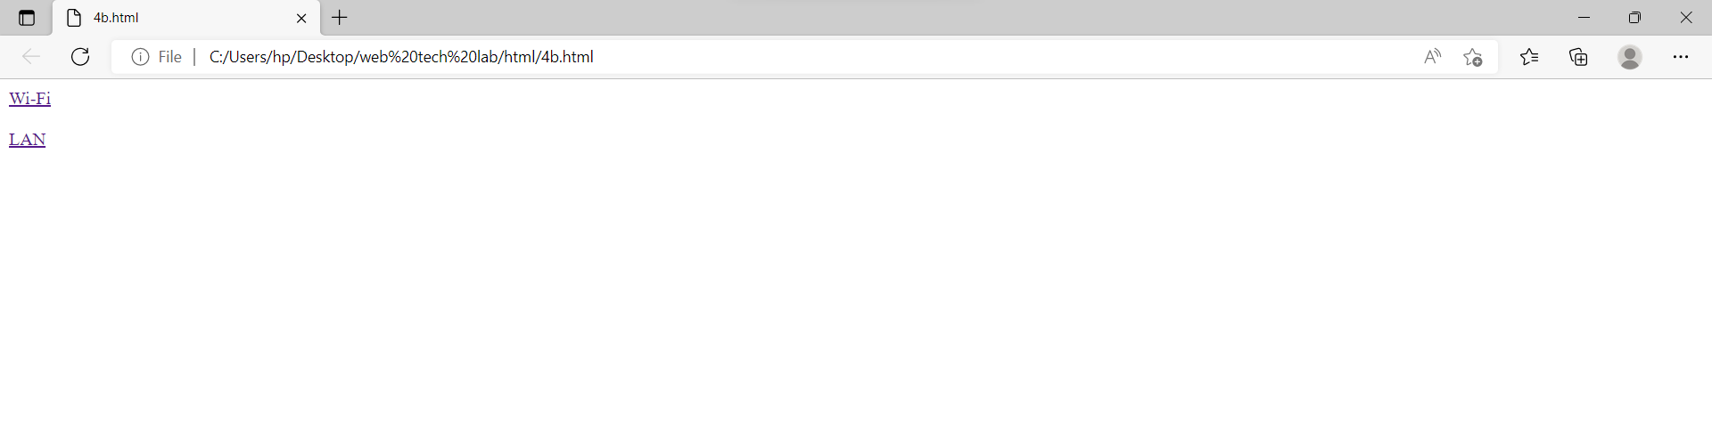

c.

<html>

    <head>

    </head>

    <body>

        <p style="text-align:left;"><a href="https://www.microsoft.com/en-in/"><img src="https://img-prod-cms-rt-microsoft-com.akamaized.net/cms/api/am/imageFileData/RE1Mu3b?ver=5c31"></a>

        Microsoft Corporation is an American multinational technology company with headquarters in Redmond, Washington.

        It develops, manufactures, licenses, supports, and sells computer software, consumer electronics, personal computers, and related services.</p>

    </body>

</html>

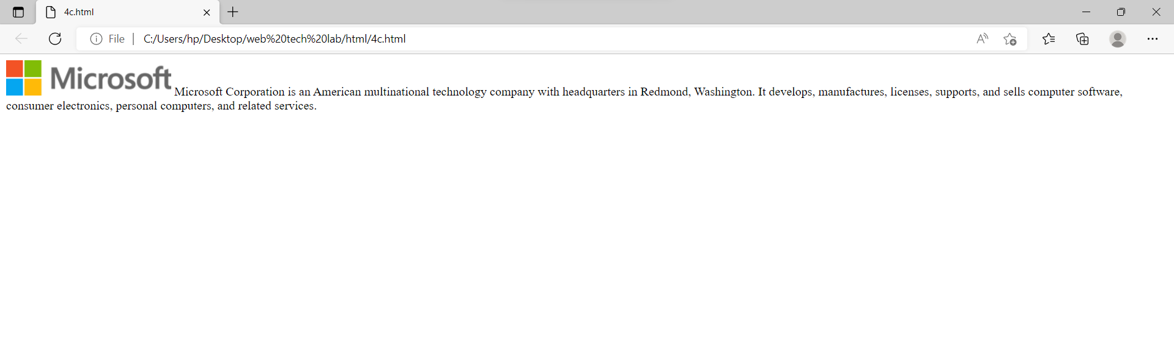

5.

a. Create a web page, showing an ordered list of the names of five of your friends.

b. Create a web page containing a nested list showing the content page of any book

c. Create a web page, showing an unordered list of names of five of your friends

Codes and Outputs:

a.

<html>

    <head>

    </head>

    <body>

        <h1>Ordered List.</h1>

        <ol>

            <li>Deepak</li>

            <li>Saleem</li>

            <li>Saketh</li>

            <li>Raju</li>

            <li>Santosh</li>

        </ol>

    </body>

</html>

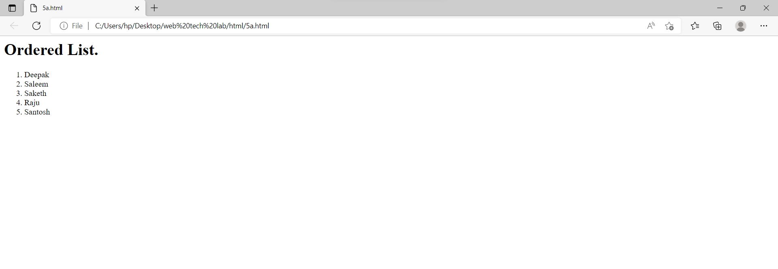

b.

<html>

    <head>

    </head>

    <body>

        <h2>Nested List</h2>

        <ol>

            <li>Introduction</li>

            <li>HTML Basics</li>

            <li>The document heading</li>

            <li>HTML Links</li>

            <ol>

                <li>Links</li>

                <li>Links Colors</li>

                <li>Link Bookmarks</li>

            </ol>

            <li>HTML Tables</li>

            <ol>

                <li>Table Borders</li>

                <li>Table Sizes</li>

                <li>Table Headers</li>

                <li>Padding & Spacing</li>

                <li>Colspan & Rowspan</li>

                <li>Table Styling</li>

                <li>Table Colgroup</li>

            </ol>

        </ol>

    </body>

</html>

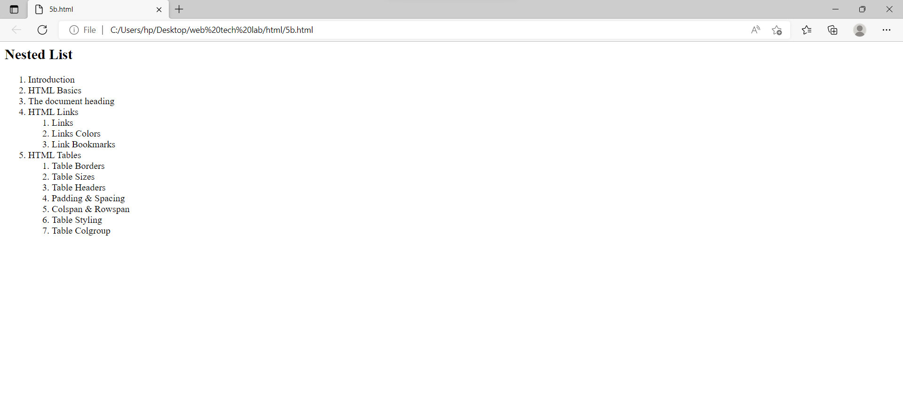

c.

<html>

    <head>

    </head>

    <body>

        <h2>Unordered List.</h2>

        <ul>

            <li>Deepak</li>

            <li>Saleem</li>

            <li>Saketh</li>

            <li>Raju</li>

            <li>Santosh</li>

        </ul>

    </body>

</html>

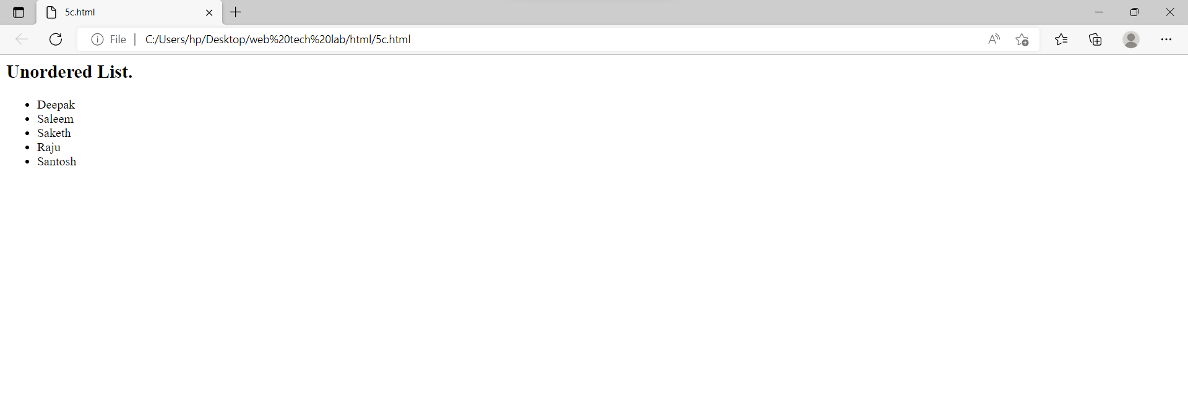

6.

a. Create a table to show your class timetable using rowspan and colspan attributes.

b. Use tables to provide layout to your HTML page describing your college infrastructure.

c. Create a web page in the following table fields

Name of train place Destination Train No Time Fair

Codes and outputs:

a.

<html>

<head>

<style>

table, th, td {

border: 1px solid black;

border-collapse: collapse;

}

tr:nth-child(even) {

  background-color: rgba(150, 212, 212, 0.4);

}

th:nth-child(even),td:nth-child(even) {

  background-color: rgba(150, 212, 212, 0.4);

}

</style>

</head>

<body>

<h2 style="color:#f20c36; text-align:center;">Time Table</h2>

<table style="width:100%">

<tr>

<th>Day</th>

<th>8:00-9:00</th>

<th>9:00-10:00</th>

<th>10:00-11:00</th>

<th>11:00-12:00</th>

<th>12:00-13:00</th>

<th>13:00-14:00</th>

<th>14:00-15:00</th>

</tr>

<tr>

<th>Monday</th>

<td colspan="3" style="text-align:center;"><-WT LAB(C-III)-></td>

<td>Lunch Break</td>

<td>DBMS</td>

<td>OS</td>

<td>SPORTS</td>

</tr>

<tr>

<th>Tuesday</th>

<td>SE</td>

<td>E&HV</td>

<td>CS</td>

<td>Lunch Break</td>

<td colspan="3" style="text-align:center;"><-DBMS LAB(C-III)-></td>

</tr>

<tr>

<th>Wednesday</th>

<td>OS</td>

<td>DBMS</td>

<td>WT</td>

<td>Lunch Break</td>

<td>SE</td>

<td>CS</td>

<td>LIBRARY</td>

</tr>

<tr>

<th>Thrusday</th>

<td>SE</td>

<td>OS</td>

<td>DBMS</td>

<td>Lunch Break</td>

<td>SOC</td>

<td>CS</td>

<td>WT</td>

</tr>

<tr>

<th>Friday</th>

<td colspan="3" style="text-align:center;"><-CS LAB(C-III)-></td>

<td>Lunch Break</td>

<td>CS</td>

<td>DBMSS</td>

<td>WT</td>

</tr>

<tr>

<th>Saturday</th>

<td colspan="2" style="text-align:center;"><-SOC LAB-></td>

<td>WT</td>

<td>Lunch Break</td>

<td>E&HV</td>

<td colspan="2" style="text-align:center;"><-COMPETITIVE CODING(E-LE)-></td>

</tr>

</table>

</body>

</html>

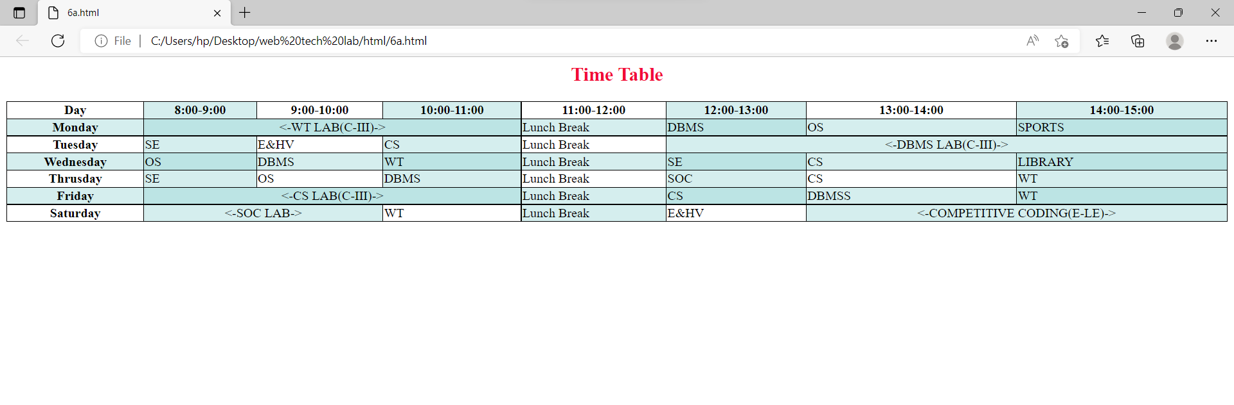

b.

<html>

<head>

<style>

table, th, td {

  border: 1px solid black;

  border-collapse: collapse;

}

tr:nth-child(even) {

  background-color: #D6EEEE;

}

tr:nth-child(odd) {

  background-color: #c0ff54;

}

</style>

</head>

<body>

<h2 style="text-align: center;">College Infrastructural Abundance</h2>

<p>It is part of the basic policy of the promoters that infrastructural self-sufficiency is a pre-requisite for better productivity and performance in all the activities, more so for academic activities. The Management has always been creating and updating academic and building infrastructure to meet the AICTE norms and standards from time to time and to make life easy and stress-free in the campus.

          Today the campus resembles a park with well laid out black-topped internal roads with avenue trees on either-side. The one k.m. approach road too is a beauty to watch. Every bit of the vacant space is covered with lawns, flower plants and gardens. It is a most environment friendly campus, full of greenery, the hills on the western side adding to the contrast of the panorama.

          The 25-bus exclusive transport saves the students and staff from the vagaries of public transport. A highly subsidized Canteen that serves lunch and stacks, a Dispensary, Bank, a Gymnasium to provide fitness regimen are a few amenities. Four A.C Seminar Halls, an Auditorium, an Open-air Theatre are the venues for co-curricular and extra-curricular events, that make life colourful and enjoyable. Perhaps, there is every facility in the campus that renowned institutes generally provide to its staff and students.</p>

<table style="width:100%">

<tr><th colspan="2">The Infrastructure</th></tr>

<tr><td>Spread </td><td> 37.41 Acres</td></tr>

<tr><th colspan="2">Build-p area:</th></th></tr>

<tr><td>R.C.C</td><td>75504 Sq.m.</td></tr>

<tr><td>Non-R.C.C</td><td>9951 Sq.m.</td></tr>

<tr><th colspan="2">Hostels:</th></tr>

<tr><td>Boys</td><td>19080 Sq.m.</td></tr>

<tr><td>Girls</td><td>10617 Sq.m.</td></tr>

<tr><th colspan="2">Building details</th></tr>

<tr><td>Lecture Halls</td><td>94</td></tr>

<tr><td>Drawing Halls</td><td>15</td></tr>

<tr><td>Engineering/Science Labs</td><td>71</td></tr>

<tr><td>Computer Centres</td><td>15</td></tr>

<tr><td>A/c Seminar Halls</td><td>04</td></tr>

<tr><th colspan="2">Amenities</th></tr>

<tr><td>Auditorium</td><td>01</td></tr>

<tr><td>Open-air Theatre</td><td>01</td></tr>

<tr><td>Transport Fleet</td><td>29 buses</td></tr>

<tr><td>Canteen,Snack bar & Dining Rooms</td><td>01</td></tr>

<tr><td>Mineral Water Plant</td><td>01</td></tr>

<tr><td>Bank</td><td>01</td></tr>

<tr><td colspan="2">Play Fields, Sports facilities & Gymnasia</td></tr>

<tr><td colspan="2">NCC and NSS Units</td></tr>

<tr><td colspan="2">Hobby Clubs</td></tr>

<tr><td colspan="2">Boys and Girls Common rooms</td></tr>

<tr><td colspan="2">Rain Water Storage Dam</td></tr>

<tr><th colspan="2">Library</th?</tr>

<tr><td>Area</td><td>1766 Sq.mt.</td></tr>

<tr><td>Volume</td><td>1,04,018</td></tr>

<tr><td>Tiles</td><td>29,165</td></tr>

<tr><td>Journals</td><td>114</td></tr>

<tr><td colspan="2">Internet / Intranet access</td></tr>

<tr><td colspan="2">Computerized Services</td></tr>

<tr><td colspan="2">INDEST Membership</td></tr>

<tr><td>Qualified Library Staff</td><td>07</td></tr>

</table>

</body>

</html>

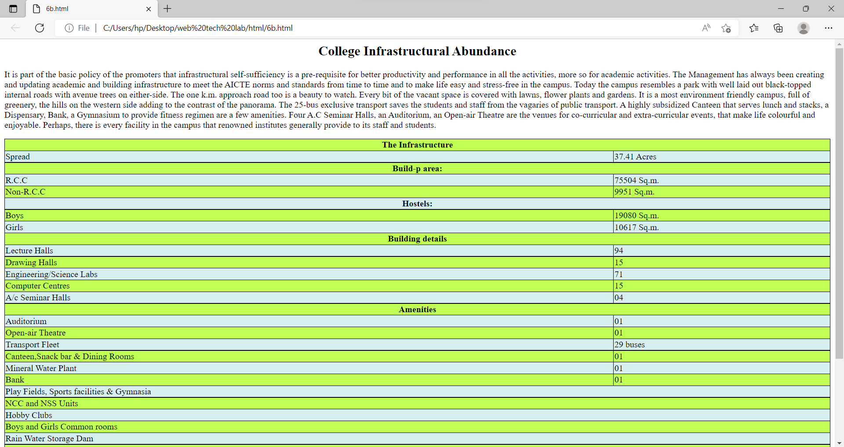

c.

<html>

    <head>

        <style>

            table, th, td {

                border: 1px solid black;

                border-collapse: collapse;

            }

        </style>

    </head>

    <body>

        <table>

            <tr>

                <th rowspan="2">Name of train</th>

                <th rowspan="2">place</th>

                <th rowspan="2">Destination</th>

                <th rowspan="2">Train No</th>

                <th colspan="2">time</th>

                <th rowspan="2">Fair</th>

            </tr>

            <tr>

                <th>Arrival</th>

                <th>Departure</th>

            </tr>

            <tr>

                <th>Rjt Duronto Express</th>

                <th>MUMBAI CENTRAL</th>

                <th>HAPA</th>

                <th>12267</th>

                <th>23:25</th>

                <th>05:55</th>

                <th>$385</th>

            </tr>

            <tr>

                <th>Vskp Duronto Express</th>

                <th>SECUNDERABAD JN</th>

                <th>VISAKHAPATNAM</th>

                <th>22204</th>

                <th>20:15</th>

                <th>06:35</th>

                <th>$345</th>

            </tr>

            <tr>

                <th>Jhelum Express</th>

                <th>Pune</th>

                <th>Jammu Tawi</th>

                <th>11077</th>

                <th>17:20</th>

                <th>09:55</th>

                <th>$715</th>

            </tr>

        </table>

    </body>

</html>

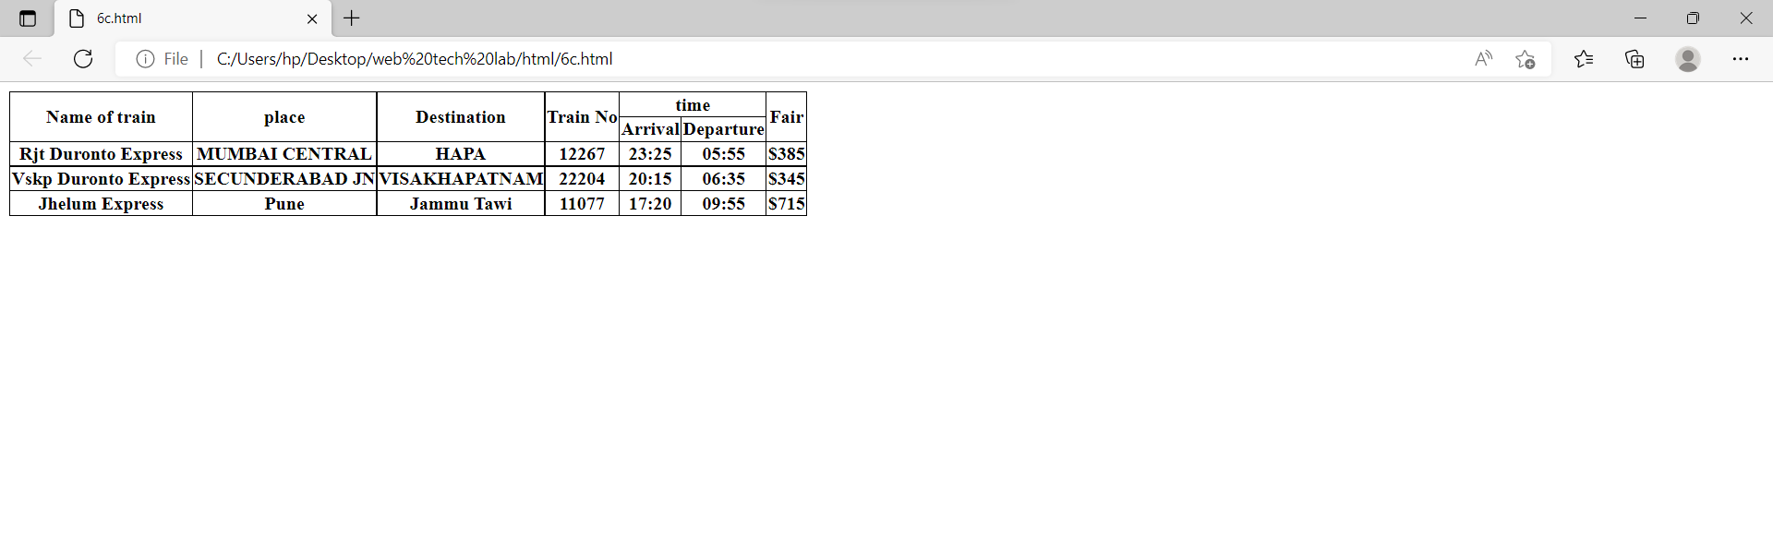

7.

a. Develop a web page having two frames that divide the Web page into two equal rows.

b. Develop a web page having two frames that divide the Web page into two equal rows and then divide the second row into two equal columns.

c. Develop a web page having frames as described in the above web page and then fill each frame with a different background colour

Codes and outputs:

a.

<html>

    <head>

    </head>

    <body>

        <iframe src="7aa.html" height=50% width=100%></iframe>

        <iframe src="7ab.html" height=50% width=100%></iframe>

    </body>

</html>

<html>

    <head>

    </head>

    <body>

        <h1>First iframe</h1>

    </body>

</html>

<html>

    <head>

    </head>

    <body>

        <h1>Second iframe</h1>

    </body>

</html>

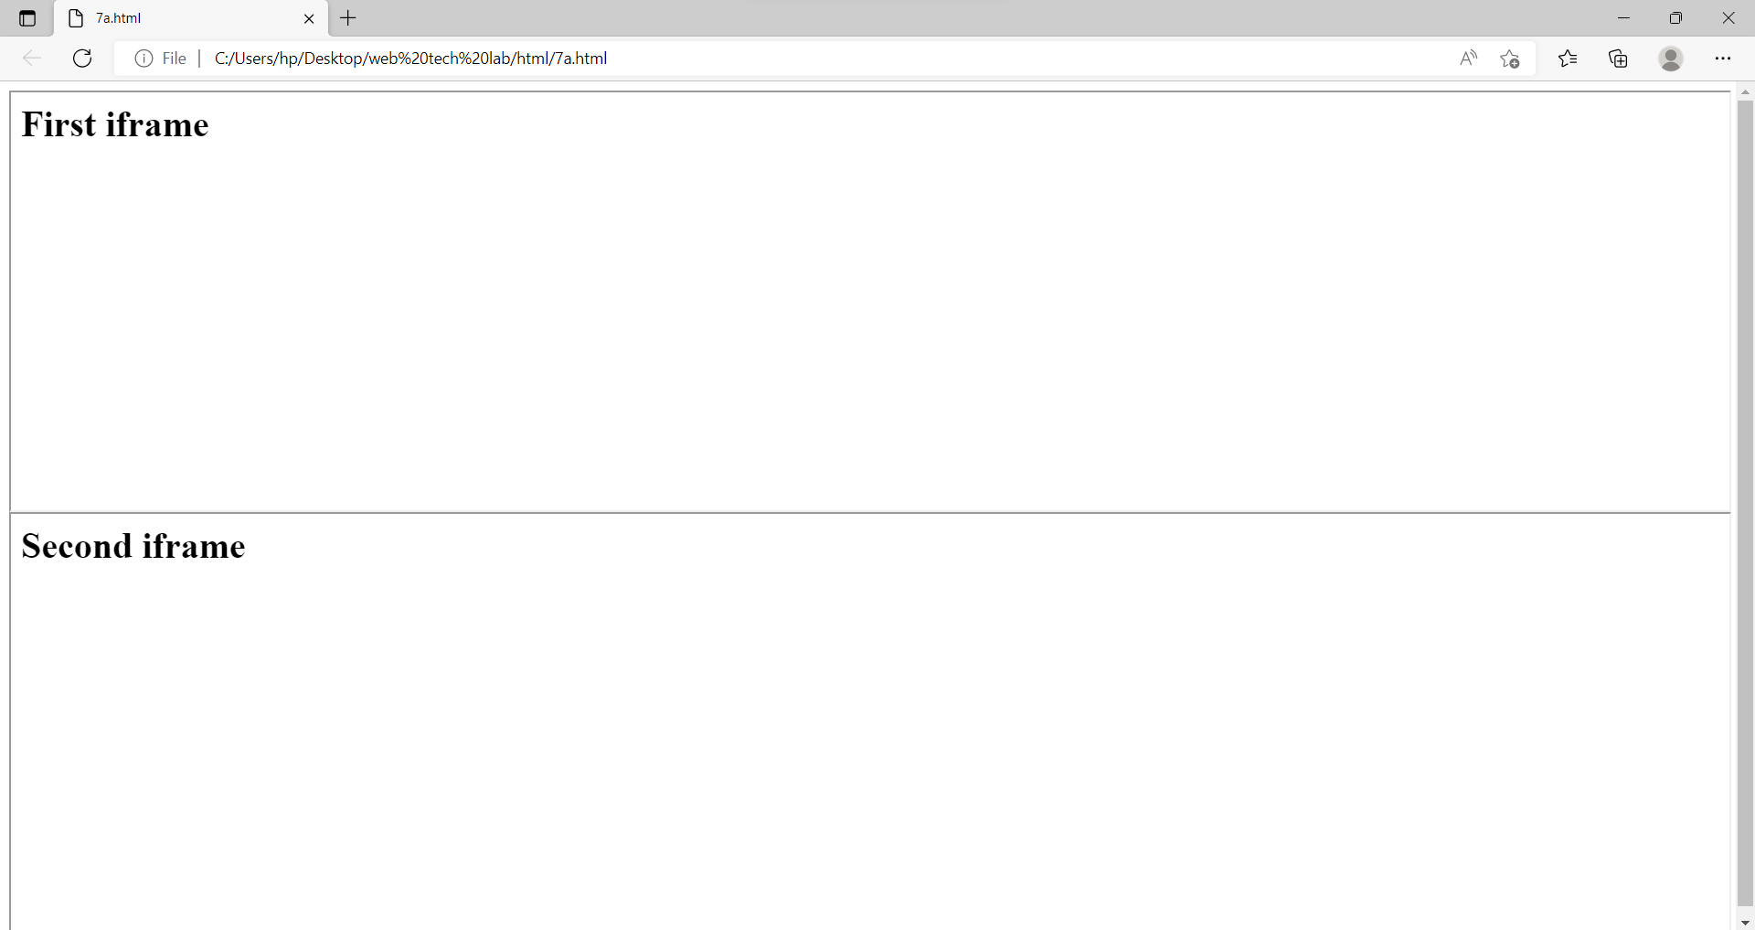

b.

<html>

    <head>

    </head>

    <body>

        <iframe src="7ba.html" height=50% width=100%></iframe>

        <iframe src="7bb.html" height=50% width=100%></iframe>

    </body>

</html>

<html>

    <head>

    </head>

    <body>

        <h1>First 1st iframe</h1>

    </body>

</html>

<html>

    <head>

    </head>

    <body>

        <iframe src="7b1.html" height=100% width=49.4%></iframe>

        <iframe src="7b2.html" height=100% width=49.4%></iframe>

    </body>

</html>

<html>

    <head>

    </head>

    <body>

        <h1>Second 1st iframe</h1>

    </body>

</html>

<html>

    <head>

    </head>

    <body>

        <h1>Second 2nd iframe</h1>

    </body>

</html>

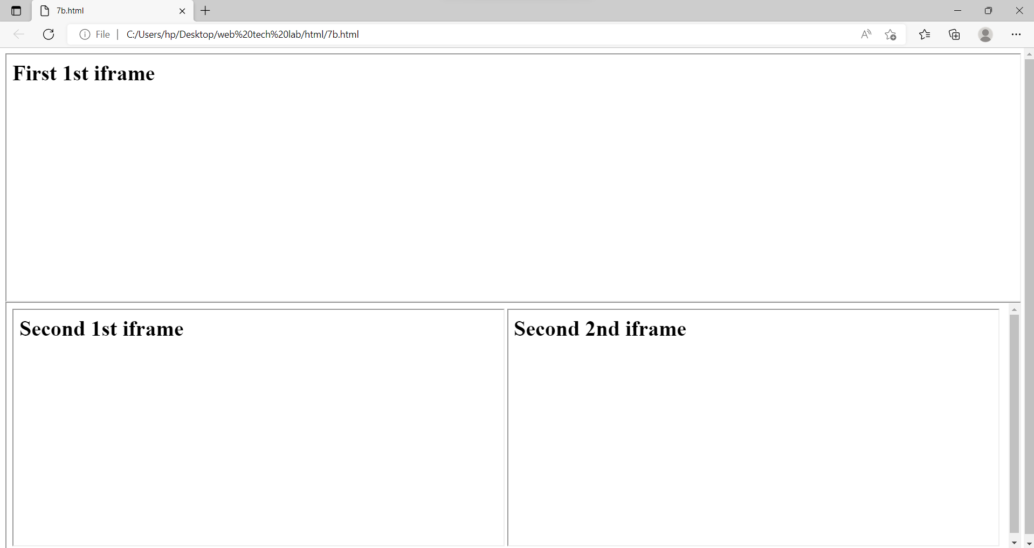

c.

<html>

    <head>

    </head>

    <body>

        <iframe src="7ca.html" height=50% width=100%></iframe>

        <iframe src="7cb.html" height=50% width=100%></iframe>

    </body>

</html>

<html>

    <head>

    </head>

    <body style="background-color:#ff0022">

        <h1>First 1st iframe</h1>

    </body>

</html>

<html>

    <head>

    </head>

    <body>

        <iframe src="7c1.html" height=100% width=49.4%></iframe>

        <iframe src="7c2.html" height=100% width=49.4%></iframe>

    </body>

</html>

<html>

    <head>

    </head>

    <body style="background-color:#ff00d9">

        <h1>Second 1st iframe</h1>

    </body>

</html>

<html>

    <head>

    </head>

    <body style="background-color:#0011ff">

        <h1>Second 2nd iframe</h1>

    </body>

</html>

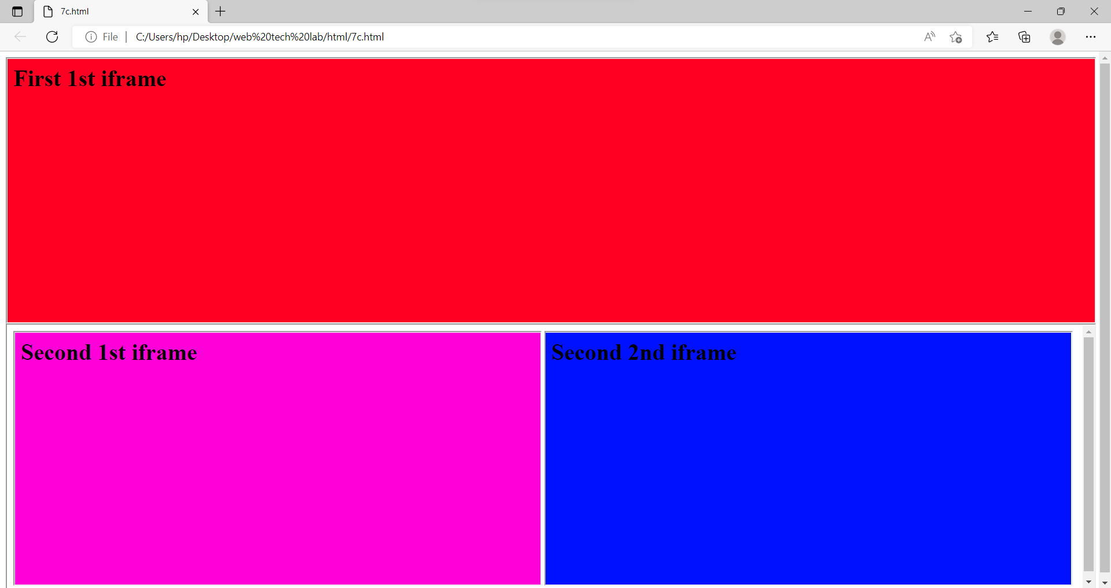

8.

a. Create your bio-data form on a web page using all input types

b. Create a web page having radio buttons labeled as name of colours. Clicking on each radio button should change the colour of the Web page

c. Embed Audio and Video into your web page

Codes and outputs:

a.

<html>

    <head>

    </head>

    <body>

        <h1>Bio data</h1>

        <form>

            <label for="name">Username : &nbsp;&nbsp;&nbsp;&nbsp;&nbsp;&nbsp;&nbsp;&nbsp;</label>

            <input type="text" id="name" name="name"><br>

            <label for="key">Password : &nbsp;&nbsp;&nbsp;&nbsp;&nbsp;&nbsp;&nbsp;&nbsp;&nbsp;</label>

            <input type="password" id="key" name="key"><br>

            <p>Gender : </p>

            <input type="radio" id="Male" name="gender" value="Male">

            <label for="Male">Male </label>

            <input type="radio" id="Female" name="gender" value="Female">

            <label for="Female">Female </label><br>

            <label for="dob">D.O.B : &nbsp;&nbsp;&nbsp;&nbsp;&nbsp;&nbsp;&nbsp;&nbsp;&nbsp;&nbsp;&nbsp;&nbsp;&nbsp;&nbsp;</label>

            <input type="date" id="dob" name="dob"><br>

            <label for="numb">Phone number : &nbsp;</label>

            <input type="number" id="numb" name="numb"><br>

            <label for="email">Email ID : &nbsp;&nbsp;&nbsp;&nbsp;&nbsp;&nbsp;&nbsp;&nbsp;&nbsp;</label>

            <input type="email" id="email" name="email"><br>

            <p>Languages Known : </p>

            <input type="checkbox" id="lan1" name="language" value="English">

            <label for="lan1">English</label>

            <input type="checkbox" id="lan2" name="language" value="Hindi">

            <label for="lan2">Hindi</label>

            <input type="checkbox" id="lan3" name="language" value="French">

            <label for="lan3">French</label><br><br>

            <label for="myfile">Profile pic : &nbsp;&nbsp;&nbsp;&nbsp;&nbsp;&nbsp;&nbsp;</label>

            <input type="file" id="myfile" name="myfile"><br><br>

            <input type="reset">

          </form>

    </body>

</html>

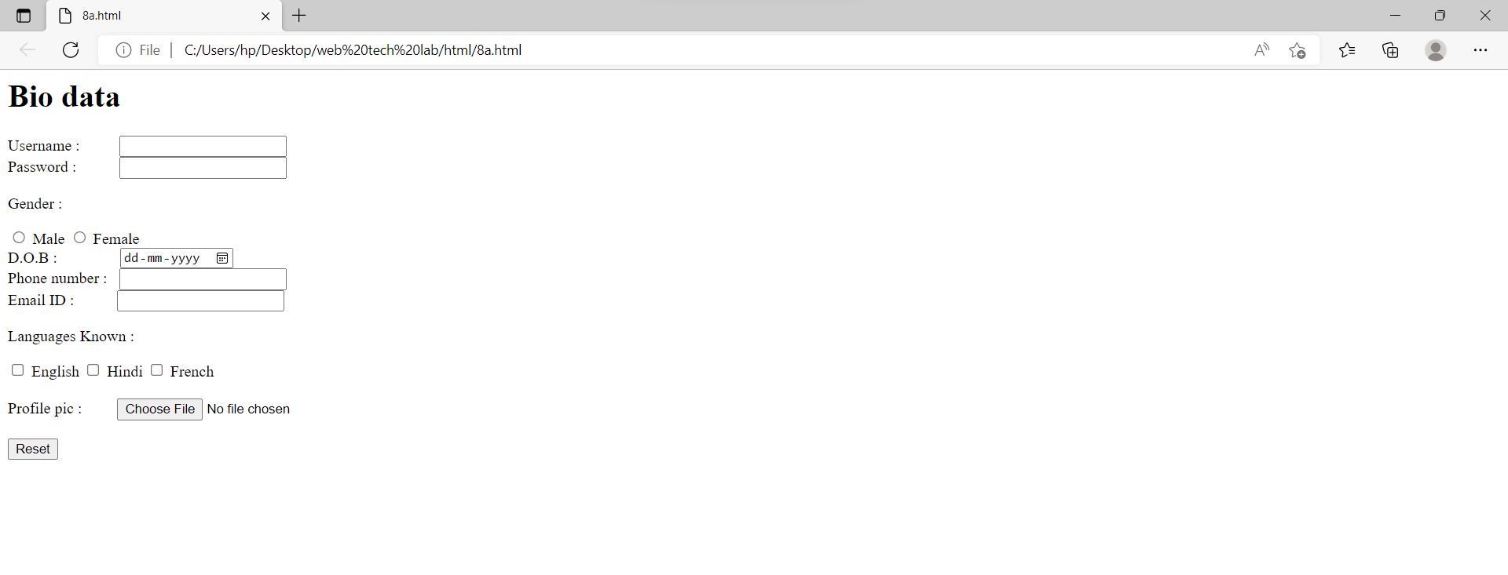

b.

<!DOCTYPE html>

<html lang="en" dir="ltr">

  <head>

    <meta charset="utf-8">

    <title>8b</title>

  </head>

  <body id="background">

    <label>blue</label>

    <input type="radio" onclick="change_color('blue');" name="color" id="blue">

    <label>red</label>

    <input type="radio" onclick="change_color('red');" name="color" id="red">

    <label>brown</label>

    <input type="radio" onclick="change_color('brown');" name="color" id="brown">

    <script type="text/javascript">

      function change_color(newcolor){

        var element=document.getElementById('background').style.background=newcolor;

      }

    </script>

  </body>

</html>

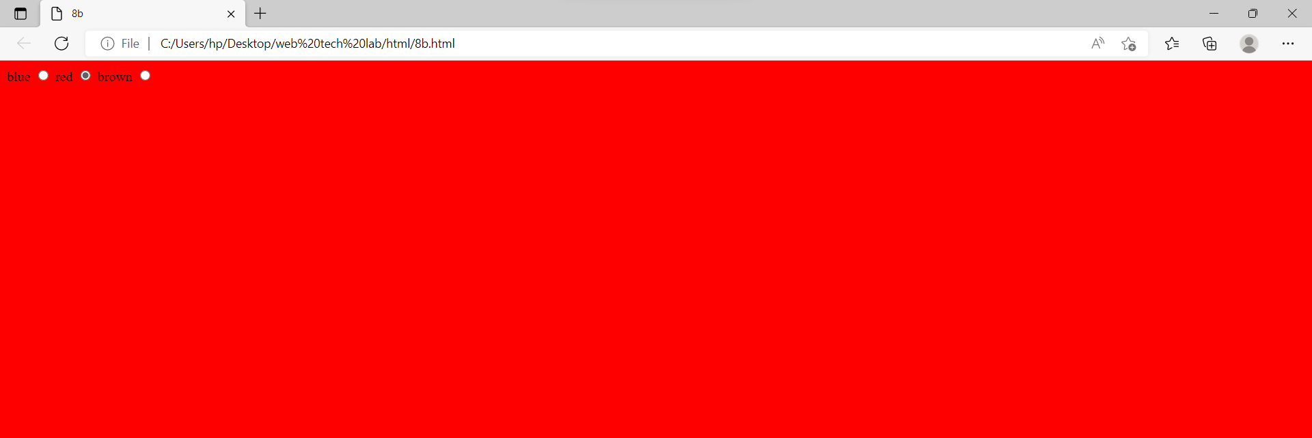

c.

<!DOCTYPE html>

<html lang="en" dir="ltr">

  <head>

    <meta charset="utf-8">

    <title>Audio & Video</title>

  </head>

  <body>

    <h3>Audio</h3>

    <audio src="1.mp3" controls="controls" width="50" heigth="50">

    </audio>

    <br>

    <br>

    <h3>Video</h3>

    <video src="" controls="controls" width="500" height="450">

    </video>

  </body>

</html>

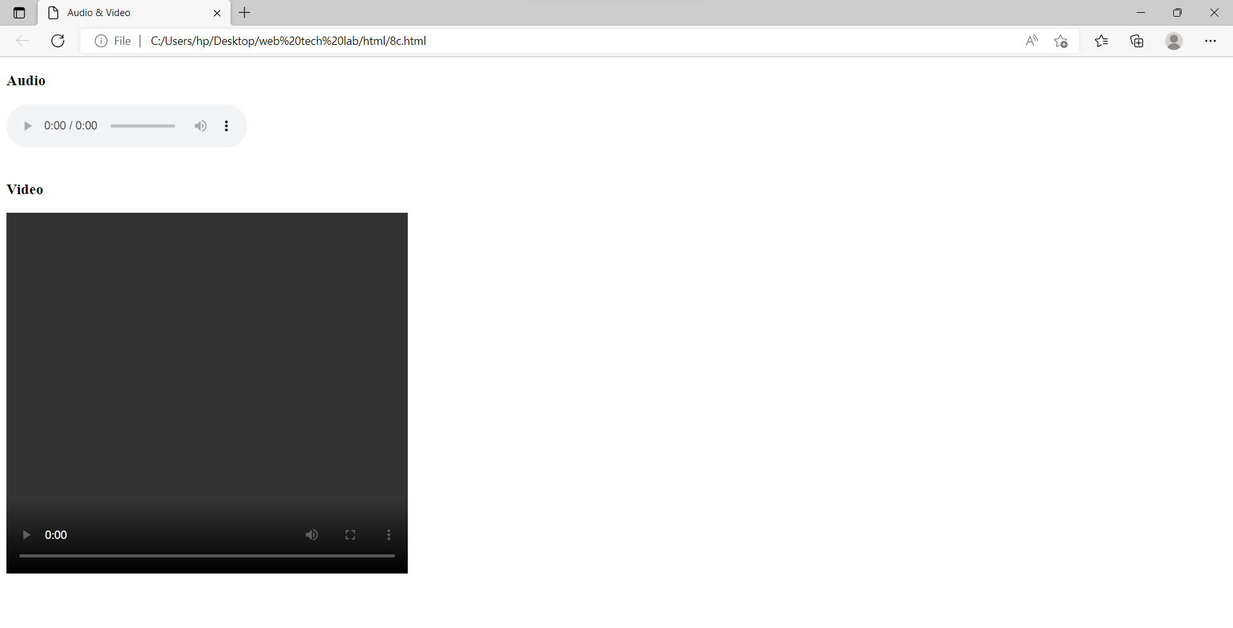

9.

Create a webpage which displays the class time table and apply the following effects on the table:

a. For the table header apply blue as the background colour and white for the colour of the text in the table header.

b. Display days in a week (Mon, Tue etc...) in bold format with the first letter in the day name in uppercase.

c. Display lunch slightly in bigger font other than the remaining text.

Codes and outputs:

a.

<!DOCTYPE html>

<html>

<head>

<style>

th

{

background-color:blue;

color:white;

border:1px solid black;

border-collapse:collapse;

}

table,td

{

border:1px solid black;

border-collapse:collapse;

}

</style>

</head>

<body>

<table>

<tr>

<th>Day\period</th>

<th>I<br>08:00-9:00</th>

<th>II<br>09:00-10:00</th>

<th>III<br>10:00-11:00</th>

<th><br>11:00-12:00</th>

<th>IV<br>12:00-1:00</th>

<th>V<br>01:00-2:00</th>

<th>VI<br>02:00-3:00</th>

</tr>

<tr>

<td>Monday</td>

<td>OS</td>

<td>CS</td>

<td>E&HV</td>

<td rowspan=6>Lunch break</td>

<td>DBMS</td>

<td>WT</td>

<td>CBA</td>

</tr>

<tr>

<td>Tuesday</td>

<td>E&HV</td>

<td>DBMS</td>

<td>SE</td>

<td>WT</td>

<td>OS</td>

<td>CBA</td>

</tr>

<tr>

<td>Wednesday</td>

<td>SE</td>

<td>OS</td>

<td>CS</td>

<td colspan=3>WT LAB</td>

</tr>

<tr>

<td>Thursday</td>

<td colspan=3>CS LAB</td>

<td>SOC</td>

<td>DBMS</td>

<td>CS</td>

</tr>

<tr>

<td>Friday</td>

<td>WT</td>

<td>SE</td>

<td>DBMS</td>

<td colspan=3>DBMS LAB</td>

</tr>

<tr>

<td>Saturday</td>

<td colspan=2>SOC LAB</td>

<td>CS</td>

<td>WT</td>

<td colspan=2>Competitive Coding</td>

</tr>

</table>

</body>

</html>

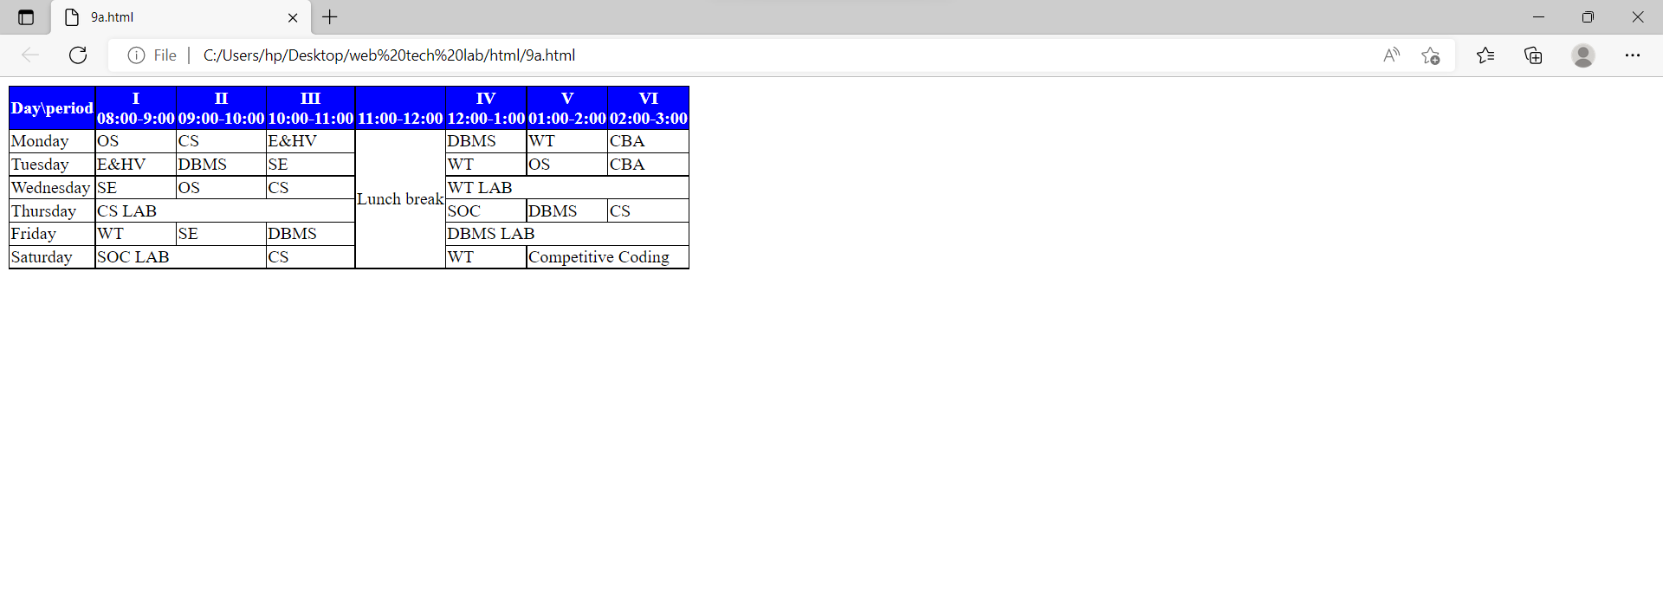

b.

<!DOCTYPE html>

<html>

<head>

<style>

th

{

background-color:blue;

color:white;

border:1px solid black;

border-collapse:collapse;

}

table,td

{

border:1px solid black;

border-collapse:collapse;

}

</style>

</head>

<body>

<table>

<tr>

<th>Day\Period</th>

<th>I<br>08:00-9:00</th>

<th>II<br>09:00-10:00</th>

<th>III<br>10:00-11:00</th>

<th><br>11:00-12:00</th>

<th>IV<br>12:00-1:00</th>

<th>V<br>01:00-2:00</th>

<th>VI<br>02:00-3:00</th>

</tr>

<tr>

<td><b><span style="text-transform:uppercase;">M</span>onday</b></td>

<td>OS</td>

<td>CS</td>

<td>E&HV</td>

<td rowspan=6>Lunch break</td>

<td>DBMS</td>

<td>WT</td>

<td>CBA</td>

</tr>

<tr>

<td><b><span style="text-transform:uppercase;">T</span>uesday</b></td>

<td>E&HV</td>

<td>DBMS</td>

<td>SE</td>

<td>WT</td>

<td>OS</td>

<td>CBA</td>

</tr>

<tr>

<td><b><span style="text-transform:uppercase;">W</span>ednesday</b></td>

<td>SE</td>

<td>OS</td>

<td>CS</td>

<td colspan=3>WT LAB</td>

</tr>

<tr>

<td><b><span style="text-transform:uppercase;">T</span>hursday</b></td>

<td colspan=3>CS LAB</td>

<td>SOC</td>

<td>DBMS</td>

<td>CS</td>

</tr>

<tr>

<td><b><span style="text-transform:uppercase;">F</span>riday</b></td>

<td>WT</td>

<td>SE</td>

<td>DBMS</td>

<td colspan=3>DBMS LAB</td>

</tr>

<tr>

<td><b><span style="text-transform:uppercase;">S</span>aturday</b></td>

<td colspan=2>SOC LAB</td>

<td>CS</td>

<td>WT</td>

<td colspan=2>Competitive Coding</td>

</tr>

</table>

</body>

</html>

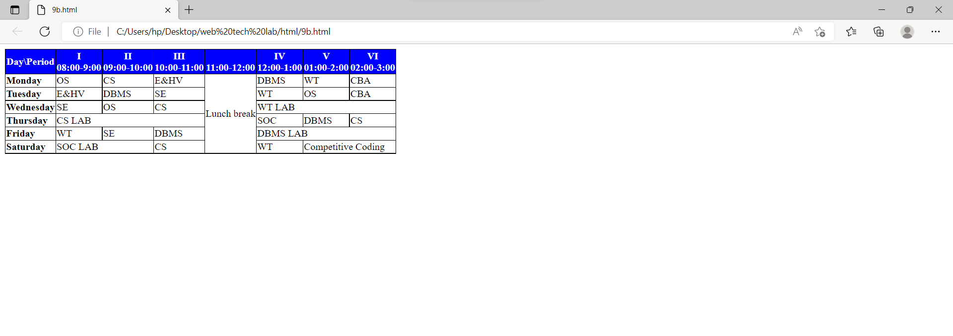

c.

<!DOCTYPE html>

<html>

<head>

<style>

th

{

background-color:blue;

color:white;

border:1px solid black;

border-collapse:collapse;

}

table,td

{

border:1px solid black;

border-collapse:collapse;

}

</style>

</head>

<body>

<table>

<tr>

<th>Day\Period</th>

<th>I<br>08:00-09:00</th>

<th>II<br>09:00-10:00</th>

<th>III<br>10:00-11:00</th>

<th><br>11:00-12:00</th>

<th>IV<br>12:00-1:00</th>

<th>V<br>01:00-2:00</th>

<th>VI<br>02:00-3:00</th>

</tr>

<tr>

<td><b><span style="text-transform:uppercase;">M</span>onday</b></td>

<td>OS</td>

<td>CS</td>

<td>E&HV</td>

<td rowspan=6><font size="+3">Lunch break</font></td>

<td>DBMS</td>

<td>WT</td>

<td>CBA</td>

</tr>

<tr>

<td><b><span style="text-transform:uppercase;">T</span>uesday</b></td>

<td>E&HV</td>

<td>DBMS</td>

<td>SE</td>

<td>WT</td>

<td>OS</td>

<td>CBA</td>

</tr>

<tr>

<td><b><span style="text-transform:uppercase;">W</span>ednesday</b></td>

<td>SE</td>

<td>OS</td>

<td>CS</td>

<td colspan=3>WT LAB</td>

</tr>

<tr>

<td><b><span style="text-transform:uppercase;">T</span>hursday</b></td>

<td colspan=3>CS LAB</td>

<td>SOC</td>

<td>DBMS</td>

<td>CS</td>

</tr>

<tr>

<td><b><span style="text-transform:uppercase;">F</span>riday</b></td>

<td>WT</td>

<td>SE</td>

<td>DBMS</td>

<td colspan=3>DBMS LAB</td>

</tr>

<tr>

<td><b><span style="text-transform:uppercase;">S</span>aturday</b></td>

<td colspan=2>SOC LAB</td>

<td>CS</td>

<td>WT</td>

<td colspan=2>Competitive Coding</td>

</tr>

</table>

</body>

</html>

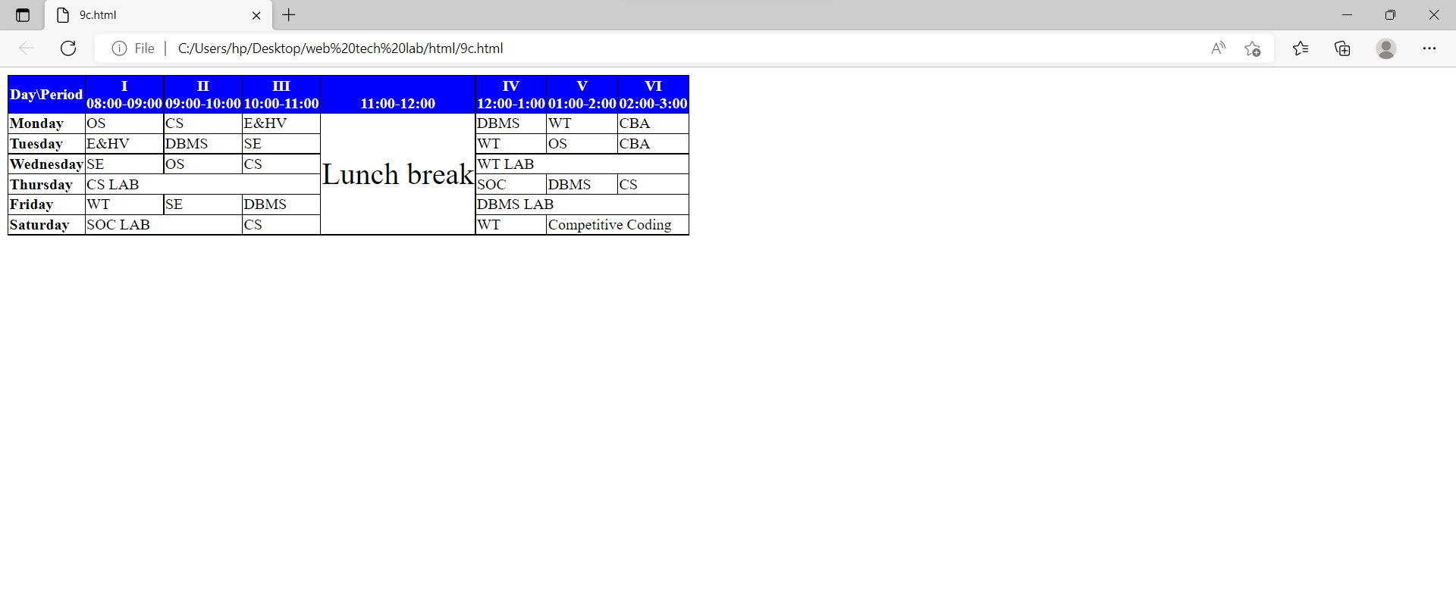

10.

a. Create a webpage which displays "Hello World" with font size 20 pixels, bold format, in "Times New Roman" font and green in colour using inline CSS, embedded CSS and external CSS.

b. Create a web page containing two images, where one image overlaps another image by using the z-index CSS property.

c. Demonstrate the usage of CSS Inheritance and Specificity with an example.

Codes and outputs:

a.

<html>

    <head>

        <style>

            p{

                color:green;

                font-style:"Times New Roman";

                font-size:20px;

                font-weight: bold;

            }

        </style>

    </head>

    <body>

        <p>Hello World !</p>

    </body>

</html>

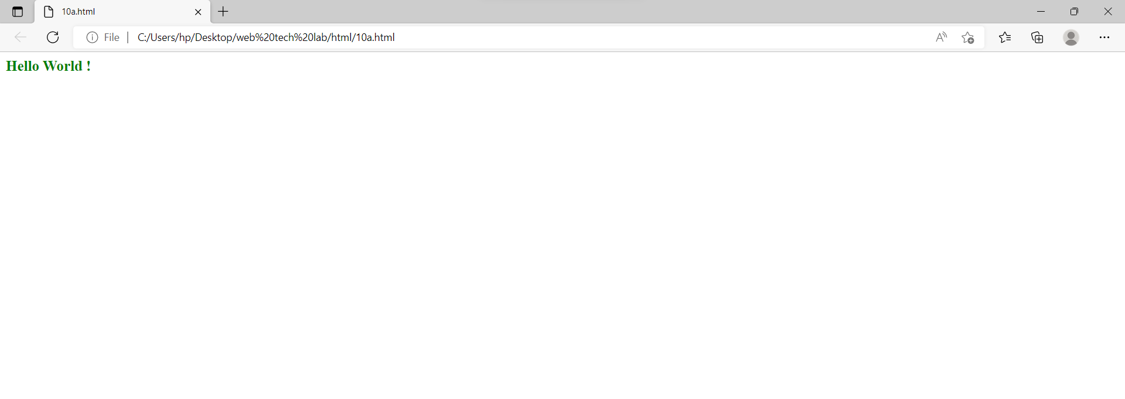

b.

<html>

<head>

<title>Example of CSS Layers Effect</title>

<style>

    .container{

        position: relative;

    }

    .box{

        width: 150px;

        height: 150px;

        opacity: 0.7;

        position: absolute;

    }

    .red{

        z-index: 1;

    }

    .green{

        top: 30px;

        left: 30px;

        background: #00ff00;

        z-index: 2;

    }

</style>

</head>

<body>

    <div class="container">

        <div class="box red"><img src="https://assets-in.bmscdn.com/discovery-catalog/events/tr:w-400,h-600,bg-CCCCCC:w-400.0,h-660.0,cm-pad_resize,bg-000000,fo-top:oi-discovery-catalog@@icons@@like_202006280402.png,ox-24,oy-617,ow-29:q-80/et00302403-jmbsnyjdek-portrait.jpg" alt="W3Schools.com"></div>

        <div class="box green"><img src="https://assets-in.bmscdn.com/discovery-catalog/events/tr:w-400,h-600,bg-CCCCCC:w-400.0,h-660.0,cm-pad_resize,bg-000000,fo-top:oi-discovery-catalog@@icons@@like_202006280402.png,ox-24,oy-617,ow-29:q-80/et00302403-jmbsnyjdek-portrait.jpg" alt="W3Schools.com"></div>

    </div>

</body>

</html>

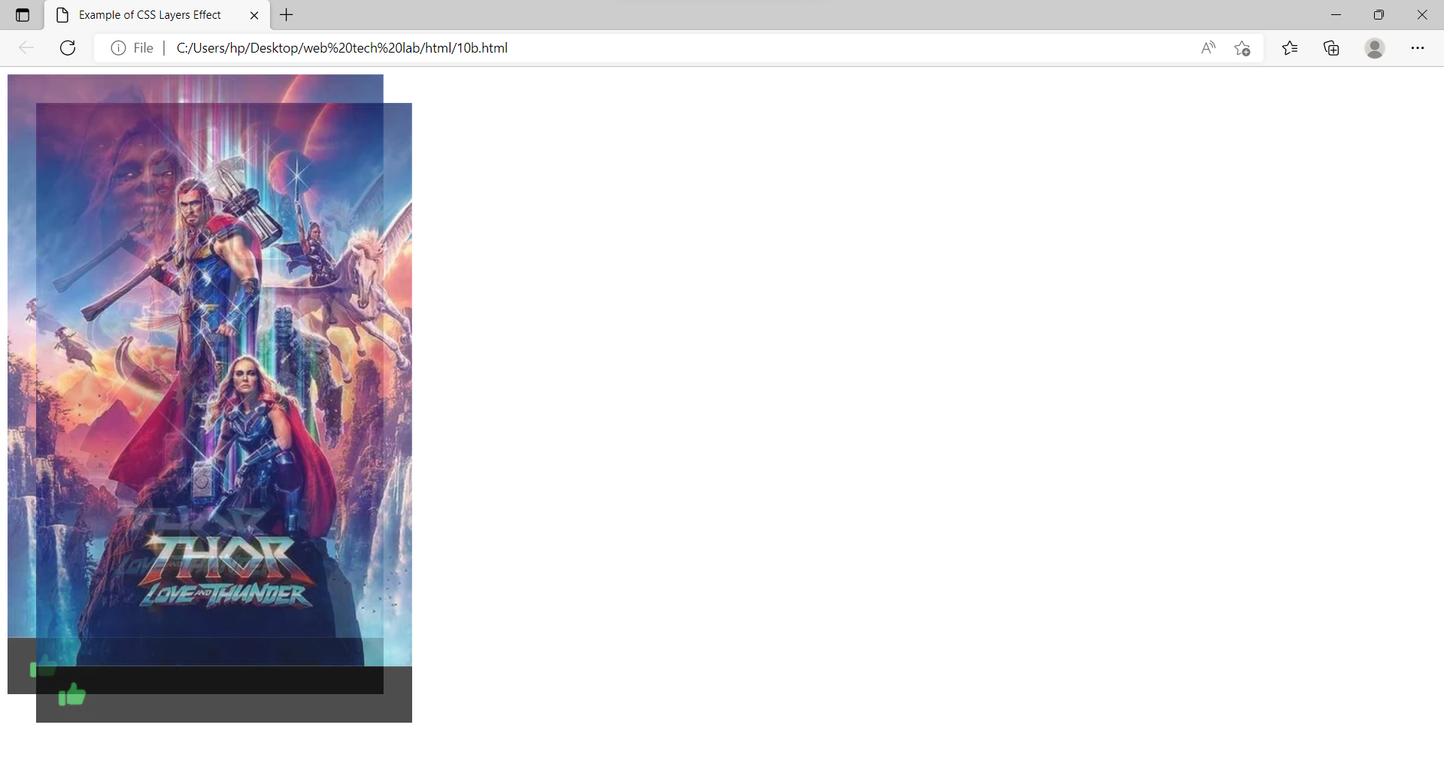

c.

<!DOCTYPE html>

<html>

<head>

<title>inheritance and specificity</title>

<style>

#id

{

color:red;

}

class

{

color:tomato;

}

p

{

color:cyan;

}

</style>

</head>

<body>

<p class="id" style="color:blue;" >paragraph id selector vs inline style</p>

<p class="class"  style="color:pink;">paragraph class selector vs inline style</p>

<p style="color:orange;">paragraph element selector vs inline style</p>

</body>

</html>

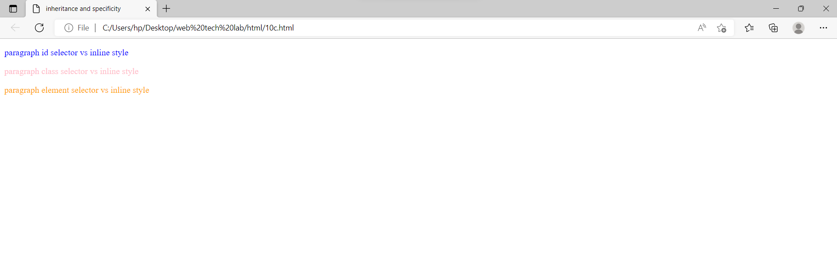

11.

a. Create a div element with a width and height of 500px. Create a diagonal linear gradient using the colors of the rainbow—Red, Orange, Yellow, Green, Blue, Indigo, Violet. (Linear Gradient)

b. Create a div element with a width and height of 500px. Create a radial gradient with three colors. Start the gradient in the bottom-left corner with the colors changing as they move along the gradient line to the right. (Radial Gradient)

c. Create an infinite animation of an element moving in a square pattern. (Animation)

Codes and outputs:

a.

<!DOCTYPE html>

<html>

<head>

<title>webpage</title>

<style>

div

{

width=500px;

height:400px;

border:3px solid black;

margin:10px;

padding:5px;

background-image:linear-gradient(to bottom right,red,orange,yellow,green,blue,indigo,violet);

}

</style>

</head>

<body>

<div></div>

</body>

</html>

<!DOCTYPE html>

<html lang="en" dir="ltr">

  <head>

    <meta charset="utf-8">

    <title>Linear gradient</title>

    <style type="text/css">

      #angle{

        width:500px;

        height:500px;

        border:3px solidpurple;

        padding: 5px 20px;

        text-align:center;

        background:linear-gradient(to bottom right,red,orange,yellow,green,blue,indigo,violet);

      }

    </style>

  </head>

  <body>

    <div id="angle">

      <h2>

       linear gradient

    </h2>

    </div>

  </body>

</html>

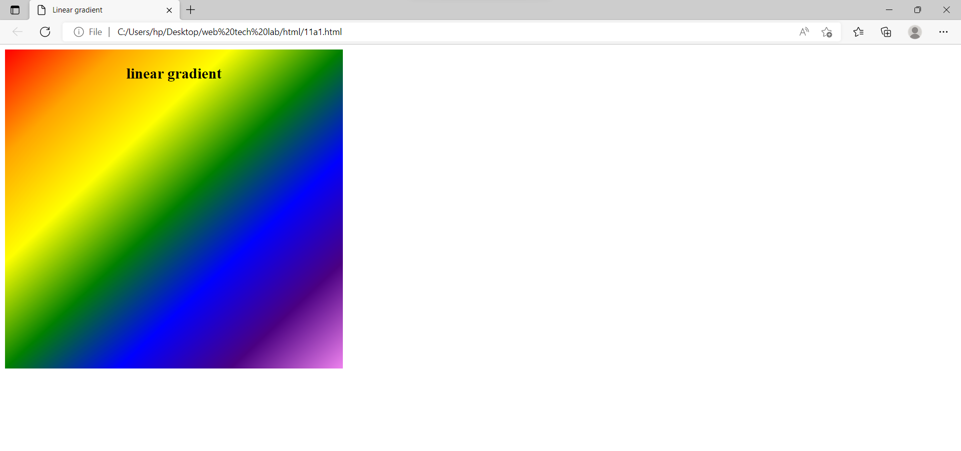

b.

<!DOCTYPE html>

<html>

<head>

<title>web page</title>

<style>

div

{

width:500px;

height:500px;

border:1px solid black;

padding:5px 5px;

margin:50px 50px;

background-image:radial-gradient(ellipse at bottom left ,yellow,red,blue);

}

</style>

</head>

<body>

<div></div>

</body>

</html>

<!DOCTYPE html>

<html lang="en" dir="ltr">

  <head>

    <meta charset="utf-8">

    <title>11b</title>

    <style type="text/css">

      #angle{

        width:500px;

        height:500px;

        border:3px solidpurple;

        padding: 5px 20px;

        text-align:center;

        background:radial-gradient(red,yellow,green);

      }

    </style>

  </head>

  <body>

    <div id="angle">

      <h2>

      radial gradient

    </h2>

    </div>

  </body>

</html>

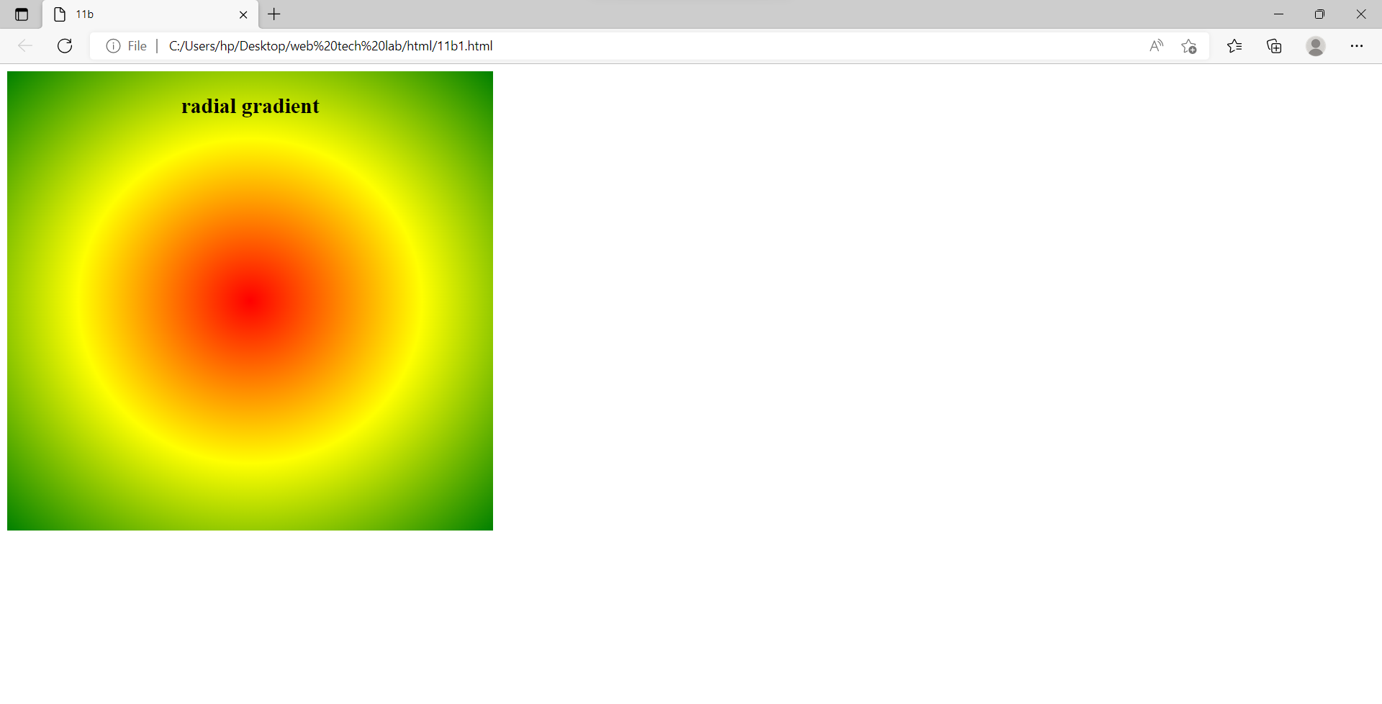

c.

<!doctype html>

<html lang="en" >

<head>

<meta charset="UTF-8">

<title>Graphics.html</title>

<style type = "text/css">

@-webkit-keyframes anim { 0% {left :0px; top: 0px;}

25% {left :100px; top: 0px;}

50% {left :100px; top: 100px;}

75% {left :0px; top: 100px;}

100% {left: 0px; top: 0px;} }

@keyframes anim{ 0% {left :0px; top: 0px;}

25% {left :100px; top: 0px;}

50% {left :100px; top: 100px;}

75% {left :0px; top: 100px;}

100% {left: 0px; top: 0px;} }

@-moz-keyframes anim { 0% {left :0px; top: 0px;}

25% {left :100px; top: 0px;}

50% {left :100px; top: 100px;}

75% {left :0px; top: 100px;}

100% {left: 0px; top: 0px;} }

@-o-keyframes anim { 0% {left :0px; top: 0px;}

25% {left :100px; top: 0px;}

50% {left :100px; top: 100px;}

75% {left :0px; top: 100px;}

100% {left: 0px; top: 0px;} }

#box { position: absolute; border: 2px solid black; -moz-animation: anim 5s linear infinite; -o-animation: anim 5s linear infinite; animation: anim 5s linear infinite; }

</style>

</head>

<body> <div id = "box"> Movingbox</div>

</body>

</html>

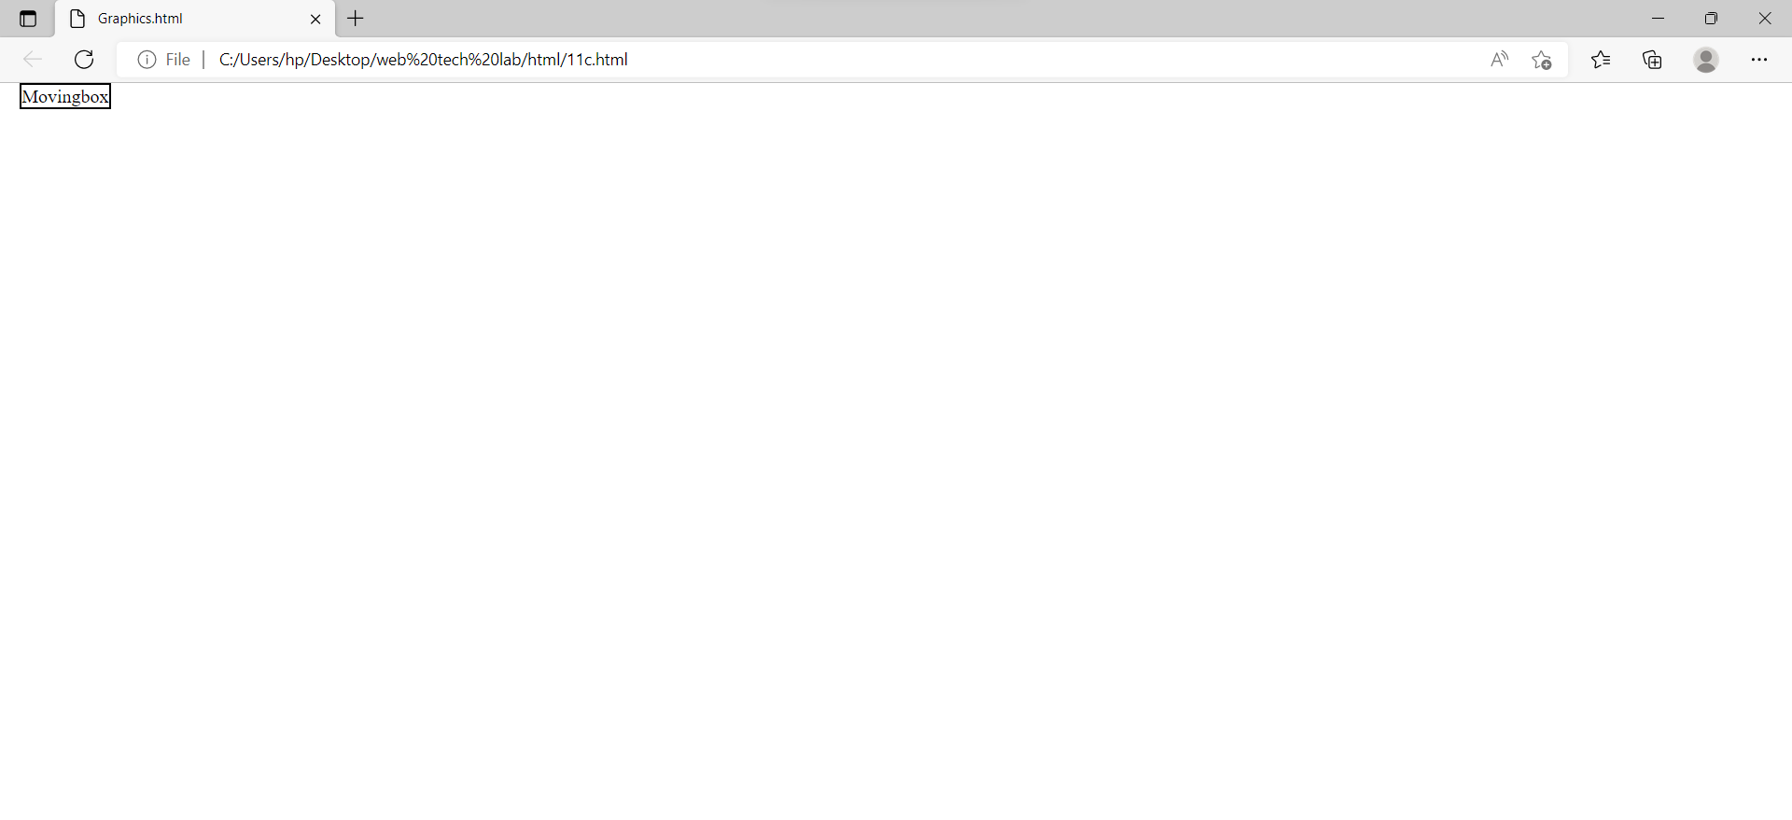

**Javascript**

1. Write a java scripts to

a) Find the given year is leap year or not

b) Compute the biggest of three numbers

c) Perform the arithmetic operations using switch statement

Codes and outputs:

a.

<html>

    <head>

    </head>

    <body>

        <h1>Leap year</h1>

        <button onclick="leap_year()">Click to enter number</button>

        <p id="demo"></p>

        <script>

            function leap_year(){

                let num = prompt("Enter number :",);

                if ((num%4 == 0 && num%100 != 0) || (num%400 == 0)){

                    document.getElementById("demo").innerHTML = num+" is a leap year.";

                }

                else{

                    document.getElementById("demo").innerHTML = num+" is not a leap year.";

                }

            }

        </script>

    </body>

</html>

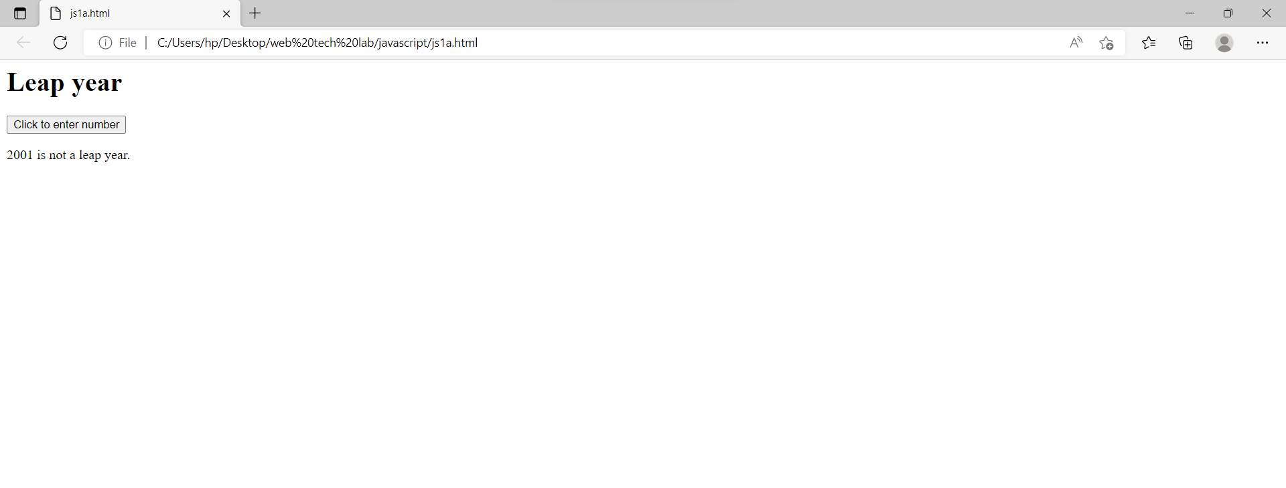

b.

<html>

    <head>

    </head>

    <body>

        <h1>Biggest of three</h1>

        <p id="demo"><p>

        <script>

            let n1 = prompt("Enter 1st number :",);

            let n2 = prompt("Enter 2nd number :",);

            let n3 = prompt("Enter 3rd number :",);

            if(n1>=n2 && n1>=n3){

                document.getElementById("demo").innerHTML = "Biggest element is " + n1;

            }

            else if(n2>=n1 && n2>=n3){

                document.getElementById("demo").innerHTML = "Biggest element is " + n2;

            }

            else{

                document.getElementById("demo").innerHTML = "Biggest element is " + n3;

            }

        </script>

    </body>

</html>

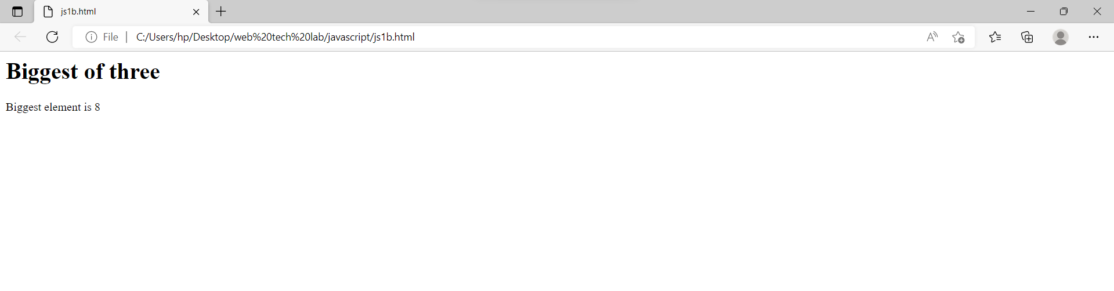

c.

<html>

    <head>

    </head>

    <body>

        <h1>Arithmetic operations</h1>

        <button onclick="cal()">Click to perform arithmetic operation</button>

        <p id="demo"></p>

        <script>

            function cal(){

                let n1 = prompt("Enter 1st number :",);

                let n2 = prompt("Enter 2nd number :",);

                let c = prompt("Enter 1 to Add, 2 to Subtract, 3 to Multiply, 4 to Divide",);

                n1 = Number(n1);

                n2 = Number(n2);

                switch (Number(c)){

                    case 1:

                    document.getElementById("demo").innerHTML = n1+n2;

                    break;

                    case 2:

                    document.getElementById("demo").innerHTML = n1-n2;

                    break;

                    case 3:

                    document.getElementById("demo").innerHTML = n1*n2;

                    break;

                    case 4:

                    document.getElementById("demo").innerHTML = n1/n2;

                    break;

                }

            }

        </script>

    </body>

</head>

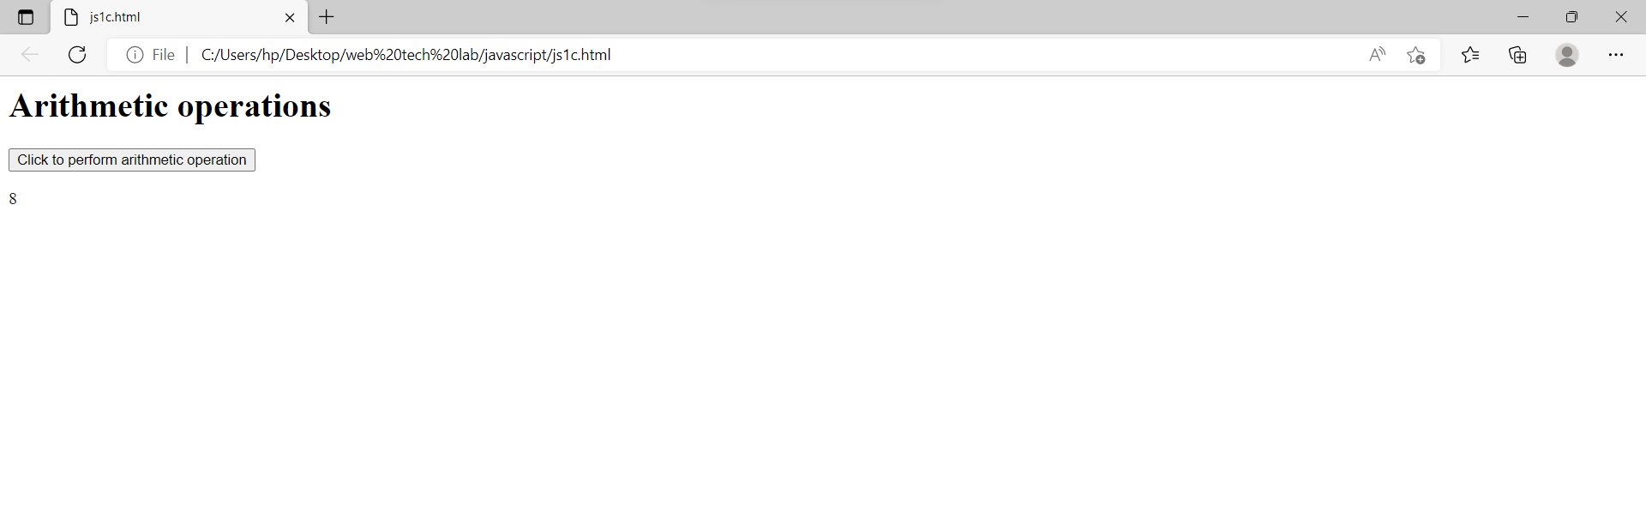

2. Write a java script to

a) Calculate the sum of the digits of a give number

b) Reverse of a given number

c) Print the first 10 natural numbers except 5

Codes and outputs:

a.

<html>

    <head>

    </head>

    <body>

        <p id="demo"></p>

        <script>

            let a = prompt("Enter string number :",);

            let s = 0;

            for(let i=0;i<a.length;i++){

                s = s + Number(a[i]);

            }

            document.getElementById("demo").innerHTML = s;

        </script>

    </body>

</html>

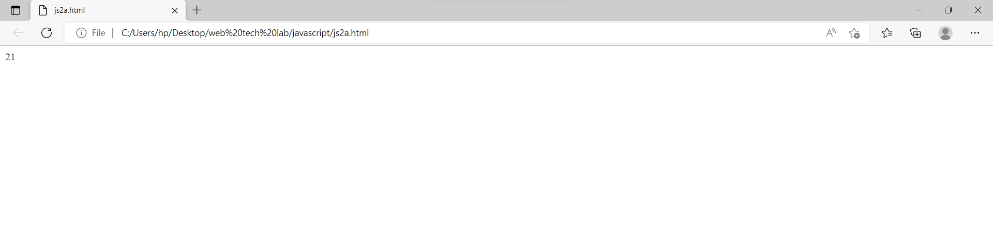

b.

<html>

    <head>

    </head>

    <body>

        <p id="demo"></p>

        <script>

            let a = prompt("Enter number :",);

            let c = 0;

            for(let i = a.length-1; i >= 0; i--){

                c = c + a[i];

            }

            document.getElementById("demo").innerHTML = c;

        </script>

    </body>

</html>

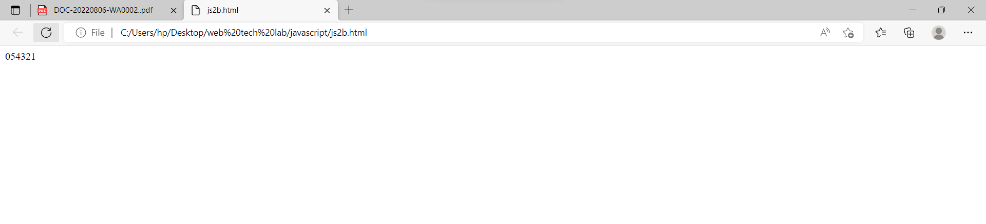

c.

<html>

    <head>

    </head>

    <body>

        <h1>Printing numbers</h1>

        <script>

            for(let i = 1; i <= 10; i++){

                if (i!=5){

                    document.write(i+" ");

                }

            }

        </script>

    </body>

</html>

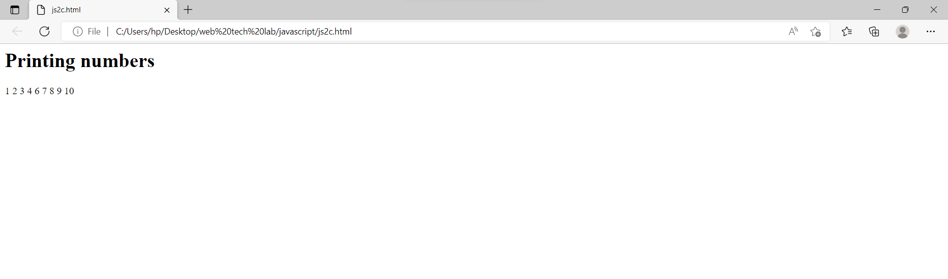

3. Write a java script to

a) Generate random numbers using user defined function

b) Find the factorial of a given number using Recursive function

c) Display a random Image by clicking a button

Codes and outputs:

a.

<htmL>

    <head>

    </head>

    <body>

        <button onclick="random()">click to generate random number</button>

        <p id="demo"></p>

        <script>

            function random(){

                let  a = Math.floor(Math.random()*(101));

                document.getElementById("demo").innerHTML = a;

            }

        </script>

    </body>

</html>

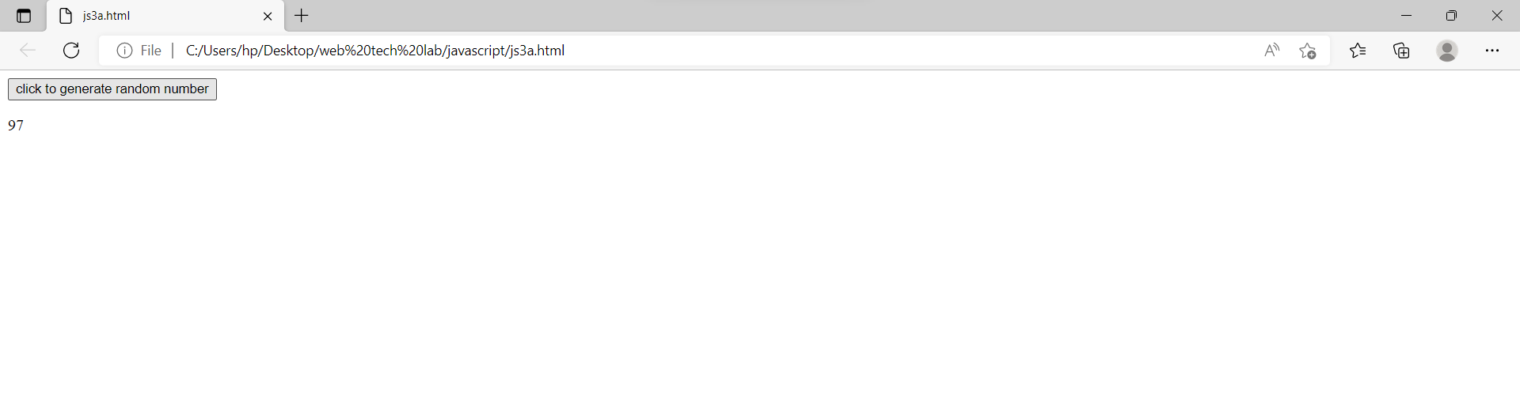

b.

<html>

    <head>

    </head>

    <body>

        <p id="demo"></p>

        <script>

            let num = prompt("Enter number",);

            let res = fact(Number(num));

            function fact(n){

                if(n>=1){

                    return n*fact(n-1);

                }

                else if(n==0){

                    return 1;

                }

                else{

                    return "Given number is not positive";

                }

            }

            document.getElementById("demo").innerHTML = res;

        </script>

    </body>

</html>

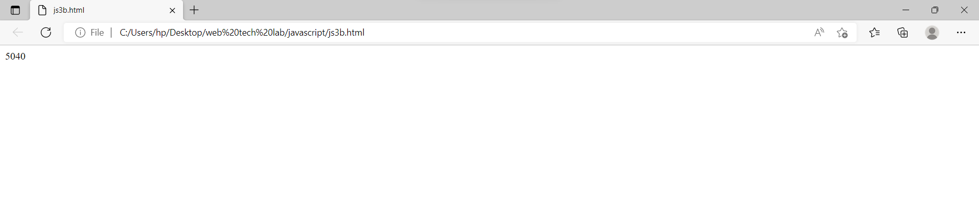

c.

<html>

    <head>

    </head>

    <body>

        <script>

            function getRandomImage() {

            var randomImage = new Array();

            randomImage[0] = "https://images.pexels.com/photos/858115/pexels-photo-858115.jpeg?auto=compress&cs=tinysrgb&dpr=1&w=500";

            randomImage[1] = "http://www.petsworld.in/blog/wp-content/uploads/2014/09/running-cute-puppies.jpg";

            randomImage[2] = "https://images.pexels.com/photos/142497/pexels-photo-142497.jpeg?auto=compress&cs=tinysrgb&dpr=1&w=500";

            randomImage[3] = "https://images.unsplash.com/photo-1543877087-ebf71fde2be1?ixlib=rb-1.2.1&ixid=eyJhcHBfaWQiOjEyMDd9&auto=format&fit=crop&w=500&q=60";

            randomImage[4] = "https://wi.wallpapertip.com/wsimgs/156-1565522_puppies-desktop-wallpaper-desktop-background-puppies.jpg";

            randomImage[5] = "https://images.unsplash.com/photo-1501265976582-c1e1b0bbaf63?ixlib=rb-1.2.1&ixid=eyJhcHBfaWQiOjEyMDd9&auto=format&fit=crop&w=500&q=60";

            var number = Math.floor(Math.random()*randomImage.length);

            return document.getElementById("result").innerHTML = '<img src="'+randomImage[number]+'" />';

        }

        </script>

        <body>

        <center><h2 style="color:green"> Random Image Generator </h2></center>

        <h4> Click the button to generate and display random images on the webpage </h4>

        <button onclick = "setInterval(getRandomImage, 2000)"> Generate Image </button>

        <br> <br>

        <span id="result" align="center"> </span>

    </body>

</html>

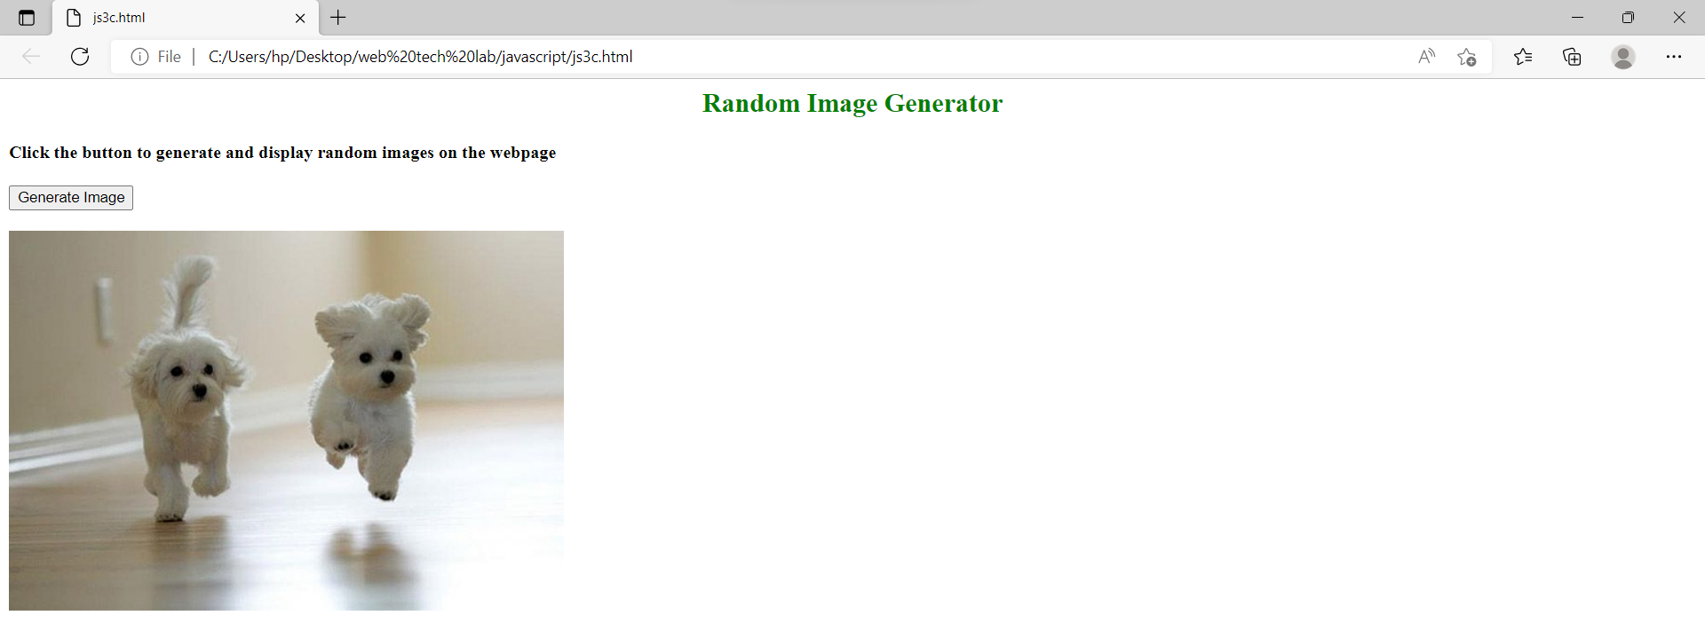

4. Write a java script to

a) Sort the array element using bubble sort technique

b) Search a given element in the set of elements using binary search technique.

c) Compute i) addition of two matrices ii) multiplication of two matrices

Codes and outputs:

a.

<html>

    <head>

    </head>

    <body>

        <script>

            let arr = [];

            let n = prompt("Enter number of elements ",);

            n = Number(n);

            for(i=0; i<n; i++){

                let a = prompt("Enter number "+(i+1)+" :",);

                arr[i] = Number(a);

            }

            function bubble_sort(){

                let j = 0;

                let k = 0;

                for(j=0; j<n; j++){

                    for(k=0; k<n-j; k++){

                        if(arr[k]>arr[k+1]){

                            let temp = arr[k];

                            arr[k] = arr[k+1];

                            arr[k+1] = temp;

                        }

                    }

                }

            }

            bubble_sort();

            document.write(arr);

        </script>

    </body>

</html>

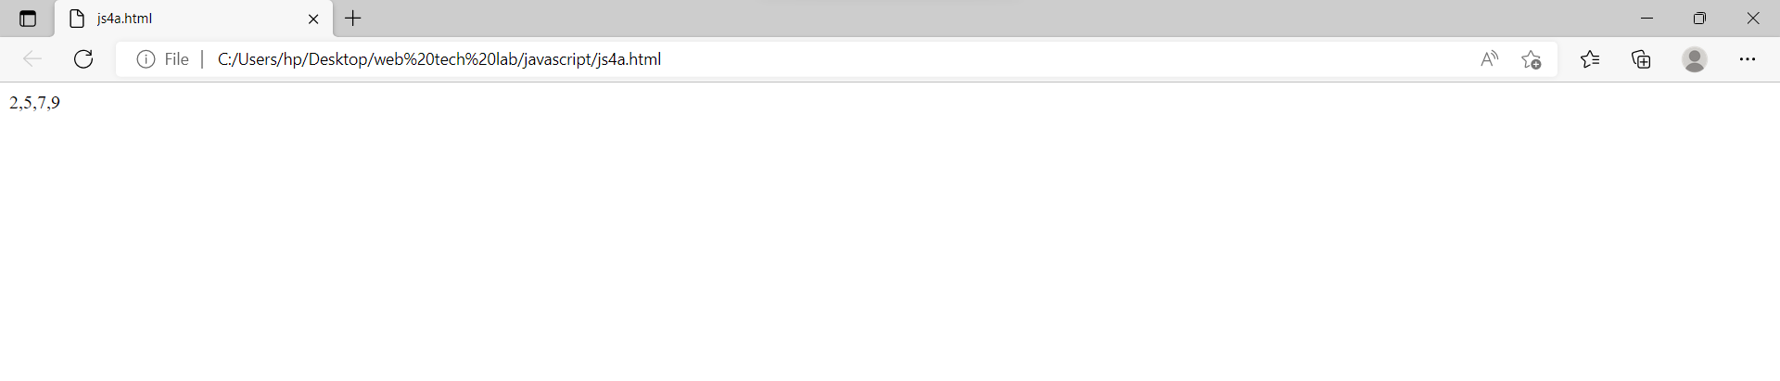

b.

<html>

    <head>

    </head>

    <body>

        <h2>Array of elements</h2>

        <p id="demo1"></p>

        <p id="demo2"></p>

        <script>

            let arr = [];

            let n = prompt("Enter number of elements ",);

            n = Number(n);

            for(i=0; i<n; i++){

                let a = prompt("Enter number "+(i+1)+" :",);

                arr[i] = Number(a);

            }

            document.getElementById("demo1").innerHTML = arr;

            let x = prompt("Enter number to search ",);

            function binarySearch(arr, n, r, x){

                if (r >= n) {

                    let mid = n + (r - n) / 2;

                    if (arr[mid] == x)

                        return mid;

                    if (arr[mid] > x)

                        return binarySearch(arr, n, mid - 1, x);

                    return binarySearch(arr, mid + 1, r, x);

                }

                return -1;

                }

            res = binarySearch(arr, 0, n-1, x);

            if(res==-1){

                document.getElementById("demo1").innerHTML = "Element "+x+" is not present in "+arr;

            }

            else{

                document.getElementById("demo2").innerHTML = "Element "+x+" is present in "+arr;

            }

        </script>

    </body>

</html>

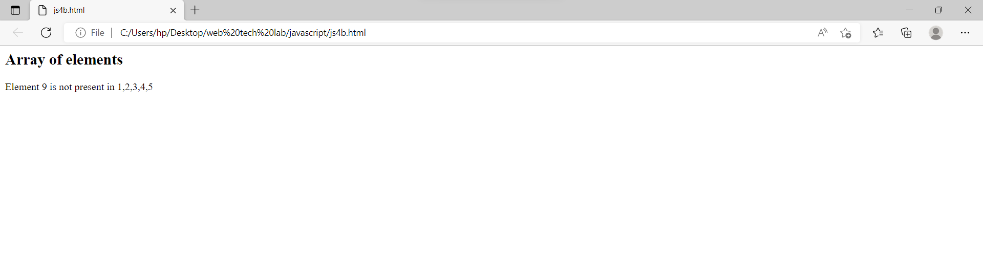

C1.

<html>

<script src="https://cdnjs.cloudflare.com/ajax/libs/mathjs/9.3.2/math.js"></script>

<body>

<h2>JavaScript</h2>

<p>Adding matrices</p>

<div id="demo"></div>

<script>

const mA = math.matrix([[0, 2, 3], [4, 4, 6], [7, 8, 8]]);

const mB = math.matrix([[1, 0, 0], [0, 1, 0], [0, 0, 1]]);

const matrixAdd = math.add(mA, mB);

document.getElementById("demo").innerHTML = matrixAdd;

</script>

</body>

</html>

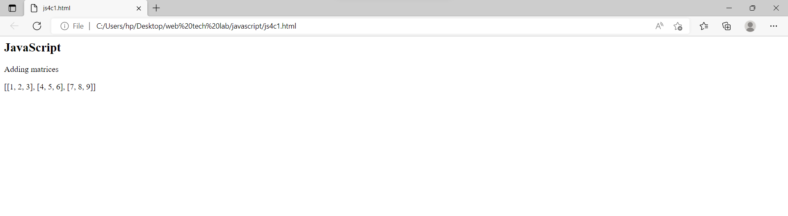

C2.

<html>

<script src="https://cdnjs.cloudflare.com/ajax/libs/mathjs/9.3.2/math.js"></script>

<body>

<h2>JavaScript</h2>

<p>Multiplying matrices with math.js</p>

<div id="demo"></div>

<script>

const mA = math.matrix([[1, 2, 3], [4, 5, 6], [7, 8, 9]]);

const mB = math.matrix([[1, 0, 0], [0, 1, 0], [0, 0, 1]]);

const matrixMult = math.multiply(mA, mB);

document.getElementById("demo").innerHTML = matrixMult;

</script>

</body>

</html>

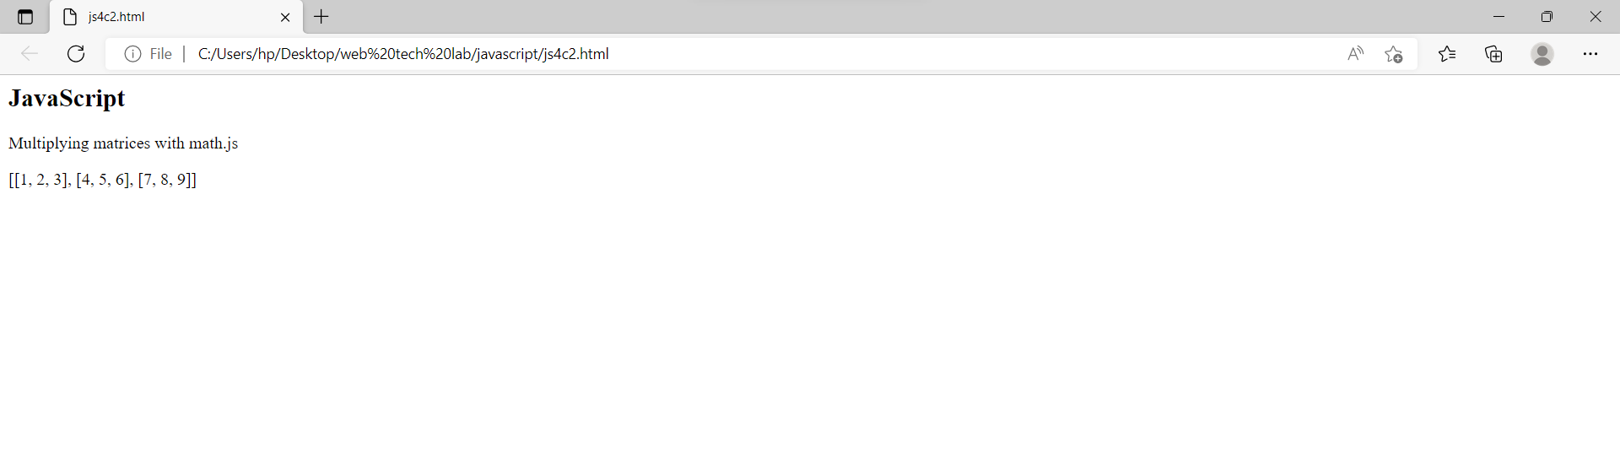

6. demonstrate collect objects

a) All collection

b) Children collection

c) Anchor collection

Codes and outputs:

<!DOCTYPE html>

<html>

<body style="background-color:lightpink;">

<h2>JavaScript HTML DOM</h2>

<p>Hello World!</p>

<p>Hello Norway!</p>

<p>Click the button to change the color of all p elements.</p>

<a name="html">HTML Tutorial</a><br>

<a name="css">CSS Tutorial</a><br>

<a name="xml">XML Tutorial</a><br>

<p>The content of the first anchor in this document is:</p>

<p id="demo"></p>

<button onclick="myFunction()">Try it</button>

<button onclick="mFunction()">Change</button>

<script>

function myFunction() {

  const myCollection = document.getElementsByTagName("p");

  for (let i = 0; i < myCollection.length; i++) {

    myCollection[i].style.color = "blue";

  }

}

function mFunction() {

const collection = document.body.children;

for (let i = 0; i < collection.length; i++) {

    collection[i].style.backgroundColor = "red";

  }

}

let content = document.getElementsByTagName("a")[0].innerHTML;

document.getElementById("demo").innerHTML = content;

</script>

</body>

</html>

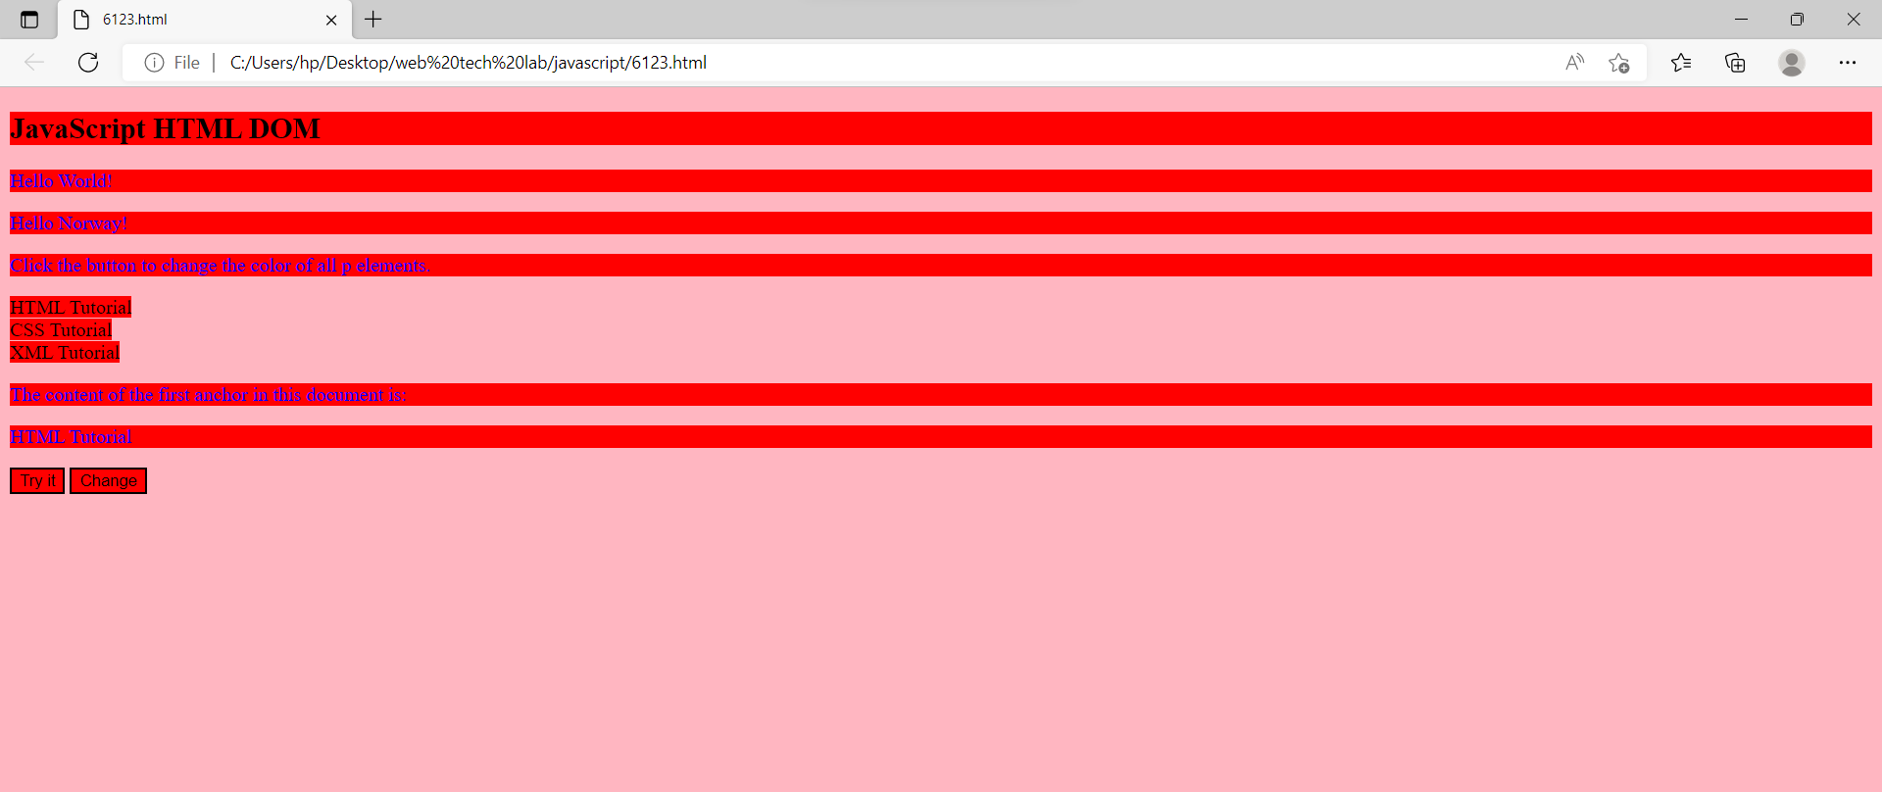

7. Demonstrate event model

a) Form events (onchange, onfocus ,onblur)

b) Mouse events (onclick, onmouesedown, onmoueseup, onmouesemove, onmoueseover)

c) Event bubbling

Codes and outputs:

a.

<!DOCTYPE html>

<html>

<body style="background-color:tomato;">

Enter your name: <input type="text" id="fname" onblur="myFunction()">

Enter your name: <input type="text" onfocus="mFunction(this)">

<p id="demo"></p>

<select id="mySelect" onchange="yFunction()">

  <option value="Audi">Audi</option>

  <option value="BMW">BMW</option>

  <option value="Mercedes">Mercedes</option>

  <option value="Volvo">Volvo</option>

</select>

<script>

function mFunction(x) {

  x.style.background = "yellow";

}

function myFunction() {

  var x = document.getElementById("fname");

  x.value = x.value.toUpperCase();

}

function yFunction() {

  var x = document.getElementById("mySelect").value;

  document.getElementById("demo").innerHTML = "You selected: " + x;

}

</script>

</body>

</html>

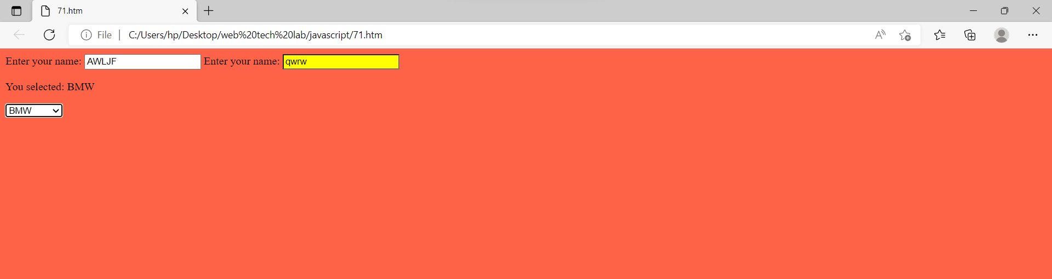

b.

<!DOCTYPE html>

<html>

<head>

<style>

div {

  width: 100px;

  height: 100px;

  border: 1px solid black;

  margin: 10px;

  float: left;

  padding: 30px;

  text-align: center;

  background-color: lightgray;

}

p {

  background-color: white;

}

body{

  background-color:lightblue;

}

</style>

</head>

<body>

<p id="myP" onmousedown="mouseDown()" onmouseup="mouseUp()">Click the text! The mouseDown() function is triggered when the mouse button is pressed down over this paragraph, and sets the color of the text to red. The mouseUp() function is triggered when the mouse button is released, and sets the color of the text to green.

</p>

<div onmousemove="myMoveFunction()">

  <p>onmousemove: <br> <span id="demo">Mouse over me!</span></p>

</div>

<button onclick="myFunction()">Click me</button>

<p id="demo2"></p>

<div onmouseover="myOverFunction()">

  <p>onmouseover: <br> <span id="demo3">Mouse over me!</span></p>

</div>

<script>

var x = 0;

var y = 0;

var z = 0;

function myMoveFunction() {

  document.getElementById("demo").innerHTML = z+=1;

}

function myOverFunction() {

  document.getElementById("demo3").innerHTML = y+=1;

}

function mouseDown() {

  document.getElementById("myP").style.color = "red";

}

function mouseUp() {

  document.getElementById("myP").style.color = "green";

}

function myFunction() {

  document.getElementById("demo2").innerHTML = "Hello World";

}

</script>

</body>

</html>

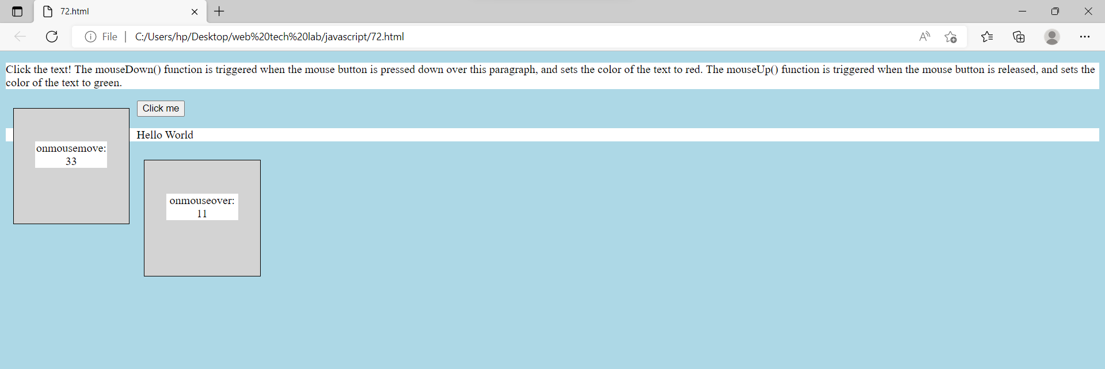

c.

<!DOCTYPE html>

<html>

<head>

    <title>

        Bubbling Event in Javascript

    </title>

</head>

<body style="background-color:lightgreen;">

    <h2>Bubbling Event in Javascript</h2>

    <div id="parent">

      <button>

          <h2>Parent</h2>

      </button>

      <button id="child">

<p>Child</p>

      </button>

    </div><br>

    <script>

        document.getElementById(

"child").addEventListener("click", function () {

            alert("You clicked the Child element!");

        }, false);

        document.getElementById(

"parent").addEventListener("click", function () {

            alert("You clicked the parent element!");

        }, false);

    </script>

</body>

</html>

